5.NF.1 Date ________________________________ Name ________________________________________

SMP2 – Reason abstractly and quantitatively

SMP4 – Model with mathematics

SMP7 – Look for and make use of structure

1. 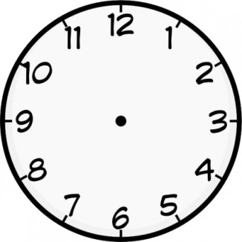 Draw a model to solve $\frac{1}{3}$ + $\frac{1}{6}$
2. Model $\frac{1}{3}$ + $\frac{1}{6}$ on the clock. What is the equivalent amount of time on the clock?
3. Write how the fraction model and the clock model are similar.

________________________________________________________________________________________________________________________________________________________________________________________________________________________________________________________________________________________________________________________________________________________________________________________________________________________________________________________________________________________________________________________________________________________________________________________________________________________________________________________________________________________________________________________________________________________________________