[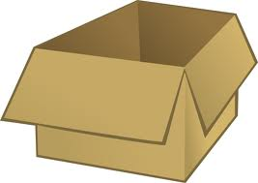](http://www.google.com/url?sa=i&rct=j&q=box&source=images&cd=&cad=rja&docid=qduOWi3KnHWXPM&tbnid=dNyOiByQC5_sWM:&ved=0CAUQjRw&url=http://www.uswatersystems.com/shop/categories/Open-Box-And-Discounted-Items/&ei=sMswUa2LJsjyqwGpsYHYDw&bvm=bv.43148975,d.eWU&psig=AFQjCNHJmsv9tEu0Ozb7fl2zAjGZZDw7mw&ust=1362238747825589)Carley order supplies to make friendship bracelets. When the box arrived the supplies were packaged in smaller boxes inside the big box. There were __ rows of ___ boxes and the boxes were stacked ___ high. How many small boxes of supplies were there?

(2, 5, 3) (3, 5, 6) (5, 6, 3) (10, 3, 6)