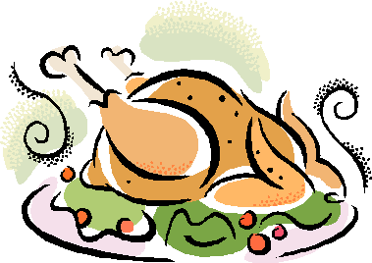 Mrs. Rhys has to cook the turkey for her family’s Thanksgiving. She chose a ___ lb. turkey. The recipe book says to cook the turkey for___ minutes per pound. How long does she need to cook the turkey?

(25, 16) (36, 14) (15 ⅓, 15) (22.5, 12)