[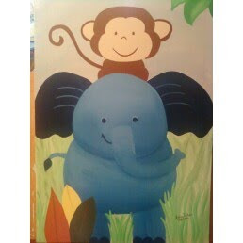](http://www.google.com/url?sa=i&rct=j&q=&esrc=s&source=images&cd=&cad=rja&uact=8&ved=0CAcQjRw&url=http%3A%2F%2Fartbyamie.blogspot.com%2F2010%2F08%2Felephant.html&ei=GTFnVaneH4XysAXq9oKgBQ&bvm=bv.93990622,d.cGU&psig=AFQjCNGHpU7ECTqCV8jL5OIaqXLeSh51Lw&ust=1432912506368708)

Ellie, the elephant is ___ inches tall. Carl, the monkey is ___inches tall. How many times taller is Ellie than Carl?

(250, 50) (300, 75) (850, 8 ½ ) (1250, 12.5)