**Fractions- Is it Fair?**

Grade 3

*Adapted from Contexts for Learning Mathematics: Investigating Fractions, Decimals, and Percents*

Standards addressed by this series of lessons: 3.NF.1, 3.NF.3b, 3.NF.3d

**Day One Outline**

**Materials Needed:**

Large chart paper

Interactive Math notebook

Connecting cubes

Markers

**Investigation**

* Tell the story about the sharing of candy bars.
  + Pose this problem to students…
    - A third grade class is sharing some candy bars. Their teacher puts them in groups and gives each group a different number of candy bars.
      * The first group had 2 candy bars shared by 4 students
      * The second group had 6 candy bars shared by 8 students
      * The third group had 3 candy bars shared by 6 students
      * The fourth group had 3 candy bars shared by 4 students

After they shared their candy bars, the students started arguing that the sharing wasn’t fair, and that some students received more of a candy bar than the others. Were they right? Or did everyone get the same amount?

* Ask students to work in small groups to determine if the sharing was fair and to find out how much of a candy bar each child received. Ask each group to create a poster showing their findings. They may use connecting cubes to work the problem, but they must show how they used them on their poster.

**Things to keep in mind…**

* Take note of the strategies students are using as they investigate how much of a candy bar each child receives.
* Make sure students show how they will divide the candy bars.
* Strategies students may use:
  + Students may cut each candy bar into landmark fractions first (½ or ¼), then cut the remainder into pieces. They may struggle with what to name each piece (what do you call ½ of ½?)
  + Students may only report their findings in the number of pieces each student will received, try to encourage them to discuss what to call each piece (2 pieces, versus 2/4 of a candy bar)
  + Students may cut each candy bar into the number of pieces that equals the number of students in a group. For example, when sharing 6 candy bars with 8 students, they may cut each candy bar into 8 pieces. And then give each student six 1/8 sized pieces. This may cause students to struggle with the idea that fractions are relations and that the size or amount of the whole matters (3.NF.3d)

**Examples of what students might do:**

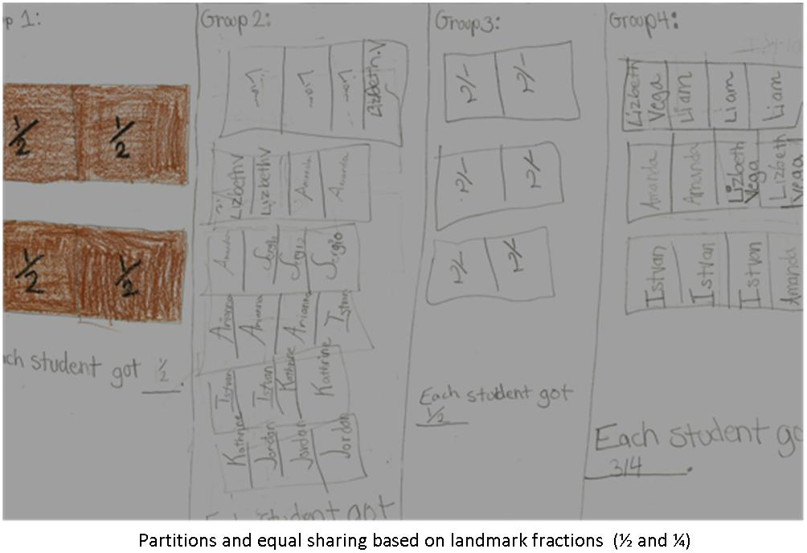

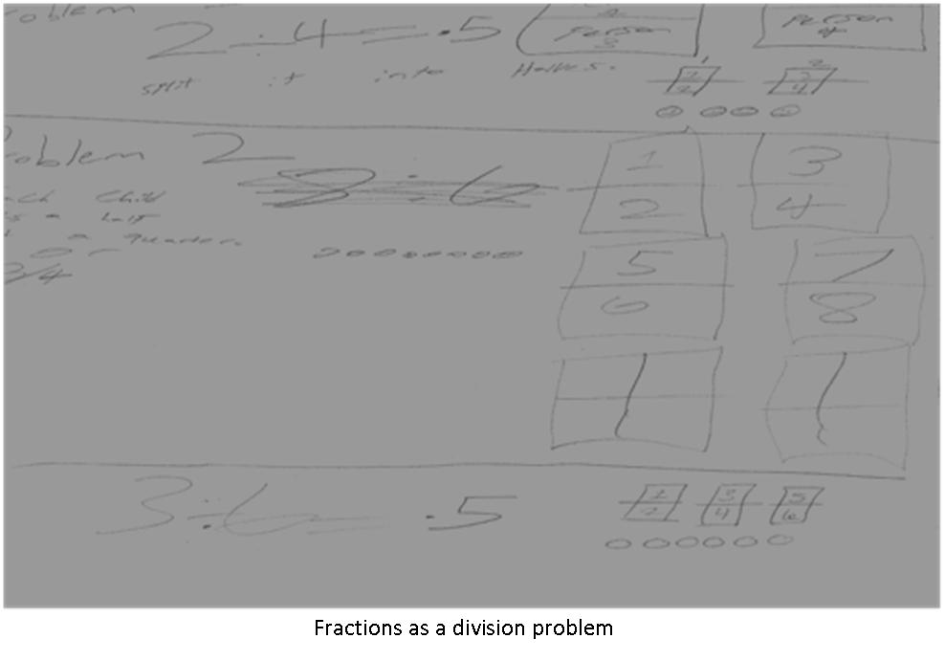

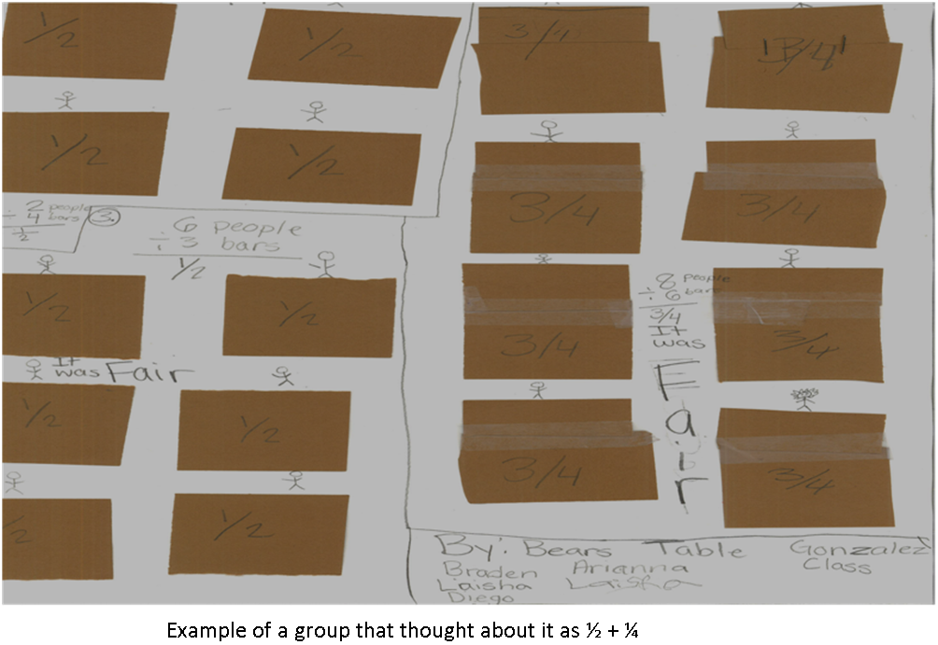

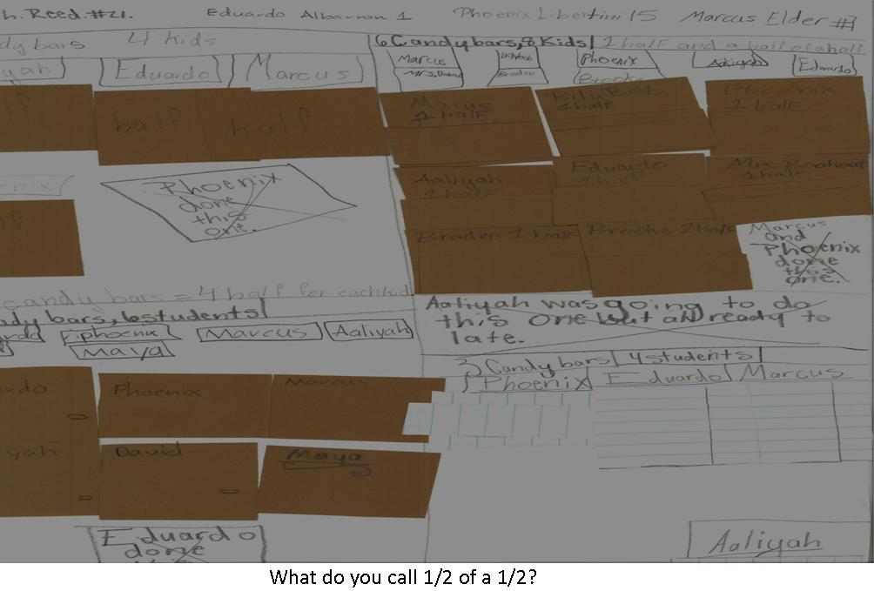

**Wrapping up the day…**

Once students have shared the candy bars, they need to compare the results to determine which group got the most. Have them determine if the sharing was fair, and make sure they finish their posters. Students will share their thinking and critique the reasoning of others during the discussion on day 2.

Give students 5-10 minutes to write down their thinking in their interactive math notebooks. They need not recreate everything they did on their poster, but instead they should craft a proof or argument around whether or not the sharing was fair. The can reflect on what was difficult for them that day and further reflect on the task so that they will be ready to defend their findings in discussion the following day.

**In preparation for Day 2**

Look over posters students made. Look at what big ideas students are showing on their posters. Plan out what questions you want to ask and how you want the conversation to flow. Look for what students struggled with and decide who will share and in what order. Look for the idea that a fraction can be thought of as division**.**

* + Usually, some student work will also illustrate a unit fraction strategy. Highlighting such a strategy will generate discussion of big ideas such as the following. The size or the amount of the whole matters (3.NF.3d)
  + With unit fractions, the greater the denominator, the smaller the piece is (3.NF.3d)
  + When naming a piece, the whole matters (what to call ½ of ½ ) (3.NF.1) (3.NF.3b)

**Day 2 Outline**

**Materials Needed:**

Posters from Day 1

Sticky notes

Interactive Math notebooks

**Beginning Day 2**

Place posters around the room. Have students do a gallery walk around the room to review and post comments on each other’s posters. As they walk around the room, have students write comments or questions and stick them to each poster. Give students 10-15 minutes to read and comment on the mathematics on the posters. Then give everyone a few minutes to read the sticky notes on their own posters before you begin the discussion.

**Discussion**

Bring students together for the discussion. Rather than just having students share their strategies, look for some big ideas to focus the conversation on, such as fractions as division, equivalence, or what to name a piece. Remember to include a discussion about whether or not the distribution was fair and how they knew.

* If a lot of students reported the amount of candy bar each student received, focus your conversation on what to call each fractional piece (3.NF.1)
* If you see different examples of equivalence (i.e. For 8 students sharing 6 candy bars, one group may have put 6/8 as an answer, another group may have called it ½ + ¼, another group may have called it ¾), ask them if they all show the same amount (3.NF.3b)
* If students notice that the answers are in the problems (4 sharing 3 is ¾, 8 sharing 6 is 6/8, etc.), focus discussion around fractions as division.

After the discussion, have students reflect in their notebooks 1 or 2 big ideas that they learned today.

**Day Three Outline**

**Materials Needed:**

Large chart paper or Sharing Candy Bars – Try 2 recording sheet

Interactive Math notebook

Connecting cubes

Markers

**Investigation**

* So, students decided the sharing wasn’t fair. Pose this new situation to students.
  + Pose this new problem to students…
    - Because the sharing wasn’t fair last time, the teacher decided to try again. She regrouped the students and gave them a different number of candy bars. Here are the new groups:
      * The first group had 3 candy bar shared by 9 students
      * The second group had 2 candy bars shared by 6 students
      * The third group had 4 candy bars shared by 12 students

Is the sharing fair this time? Did everyone get the same amount in this new situation?

* Ask students to work in small groups to determine if the sharing was fair and to find out how much of a candy bar each child received. Ask each group to create a poster showing their findings. They may use connecting cubes to work the problem, but they must show how they used them on their poster.

**Things to keep in mind…**

* Take note of the strategies students are using as they investigate how much of a candy bar each child receives.
* Make sure students show how they will divide the candy bars.
* Strategies students may use:
  + Students may cut each candy bar into the number of pieces that equals the number of students in a group. For example, when sharing 2 candy bars with 6 students, they may cut each candy bar into 6 pieces. And then give each student six 1/6 sized pieces. This may cause students to struggle with the idea that fractions are relations and that the size or amount of the whole matters (3.NF.3d)
  + Big ideas about equivalence may come out here. Highlight these conversations during the discussion.

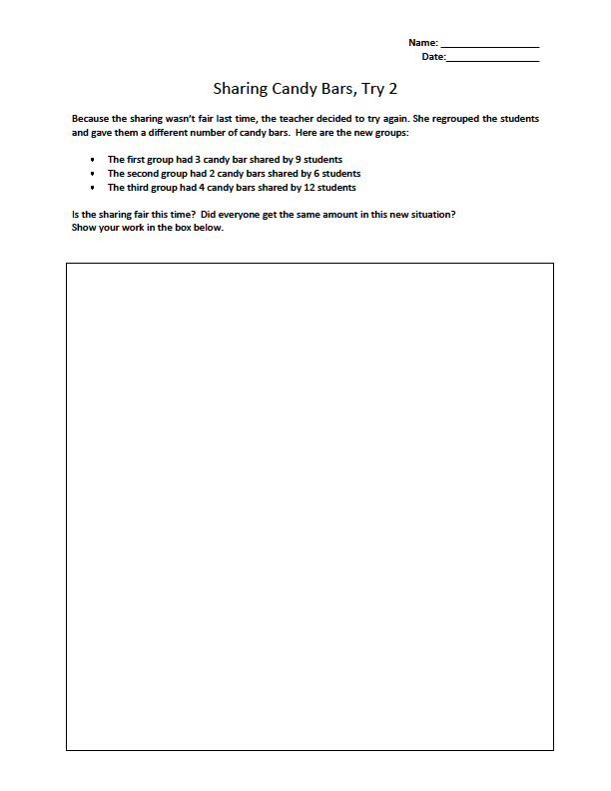

**Examples of what students might do:**

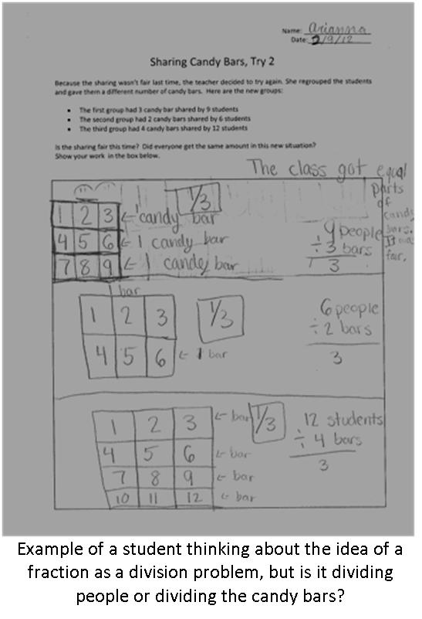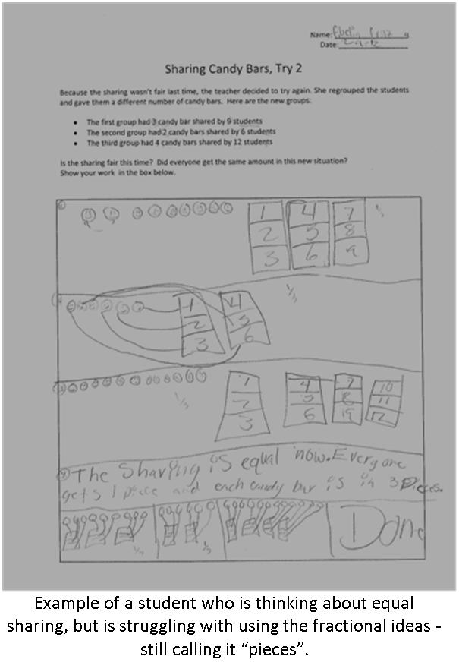

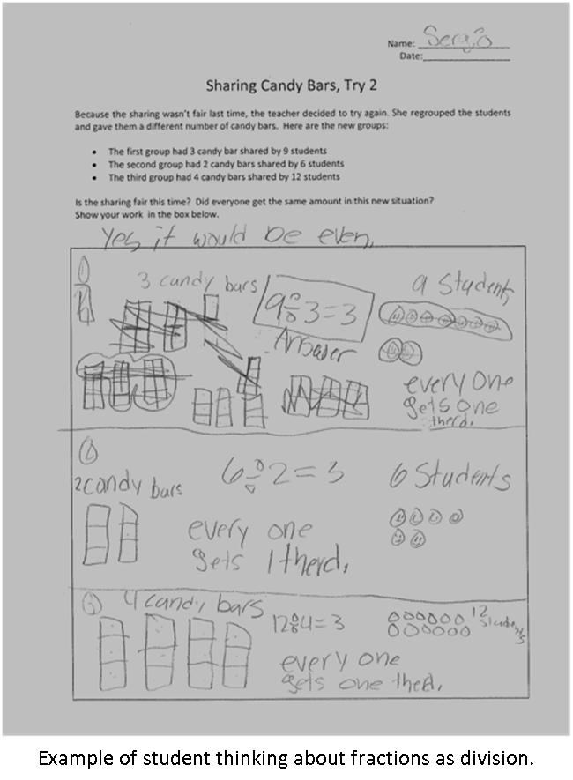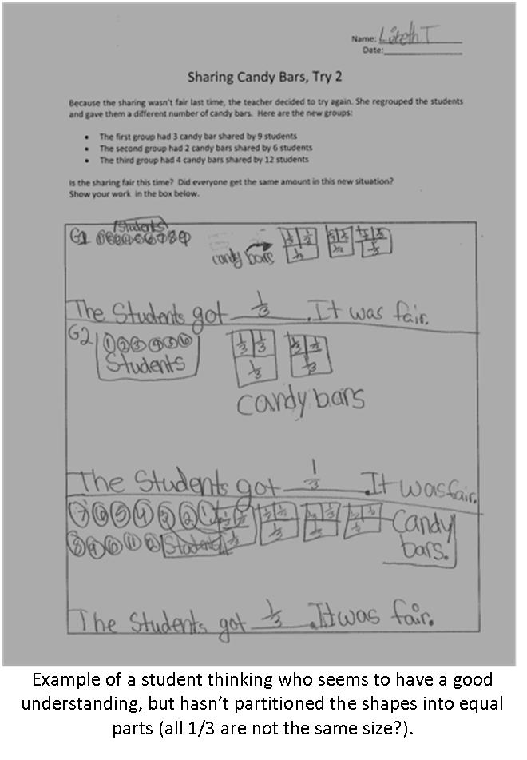

**Wrapping up the day…**

Once students have shared the candy bars, they need to compare the results to determine if the sharing was fair. Have them determine if the sharing was fair, and make sure they finish their posters. Students will share their thinking and critique the reasoning of others during the discussion on day 4.

Give students 5-10 minutes to write down their thinking in their interactive math notebooks. They need not recreate everything they did on their poster, but instead they should craft a proof or argument around whether or not the sharing was fair. The can reflect on what was difficult for them that day and further reflect on the task so that they will be ready to defend their findings in discussion the following day.

**In preparation for Day 4**

Look over posters students made. Look at what big ideas students are showing on their posters. Plan out what questions you want to ask and how you want the conversation to flow. Look for what students struggled with and decide who will share and in what order. Look for the ideas of equivalence; you will want to highlight this in the discussion. The number sets were chosen purposefully to get students to reason about equivalency. Choose posters that will highlight these big ideas (3.NF.3b)

**Day 4**

**Materials Needed:**

Posters from Day 3

Sticky notes

Interactive Math notebooks

**Beginning Day 4**

Place posters around the room. Have students do a gallery walk around the room to review and post comments on each other’s posters. As they walk around the room, have students write comments or questions and stick them to each poster. Give students 10-15 minutes to read and comment on the mathematics on the posters. Then give everyone a few minutes to read the sticky notes on their own posters before you begin the discussion.

**Discussion**

Bring students together for the discussion. Rather than just having students share their strategies, look for the big idea of equivalence. If students are still struggling with some other ideas, plan to address those in discussion as well. Remember to include a discussion about whether or not the distribution was fair and how they knew.

* If a lot of students reported the amount of candy bar each student received, focus your conversation on what to call each fractional piece (3.NF.1)
* If you see different examples of equivalence (i.e. For 12 students sharing 4 candy bars, one group may have put 4/12 as an answer, another group may have called it 1/3 ), ask them if they all show the same amount (3.NF.3b)
* If students notice that the answers are in the problems (4 sharing 3 is ¾, 8 sharing 6 is 6/8, etc.), focus discussion around fractions as division.

After the discussion, have students reflect in their notebooks 1 or 2 big ideas that they learned today.

If students need continued time on the development of these fractional ideas, here is Follow-up Task:

A third grade class is sharing some brownies. Their teacher puts them in groups and gives each group a different number of brownies.

* The first group had 2 brownies shared by 4 students
* The second group had 2 brownies shared by 8 students
* The third group had 3 brownies shared by 6 students
* The fourth group had 1 brownies shared by 4 students
* The fifth group had 1 brownie shared by 2 students

After they shared their brownies, the students started arguing that the sharing wasn’t fair, and that some students received more of a brownie than the others. Were they right? Or did everyone get the same amount?

Your Task:

* Work with your group to create a poster to show how much of a brownie each student in the group received.
* Once all groups are finished, we will share our thinking and decide if the sharing was fair.