Name: ____________________

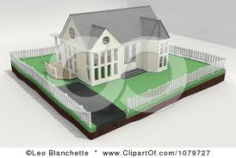Mrs. Weber is putting a fence around her yard for her puppy to play. Her yard is a rectangular shape that is ____ feet long and ____ feet wide. How many feet of fence will she need to buy to enclose her whole yard?

(10, 8) (12, 10) (15, 12) (25, 18)

Justify your solution with numbers, pictures, and/or words.