Name __________________­­­­_________________

Name __________________­­­­_________________

[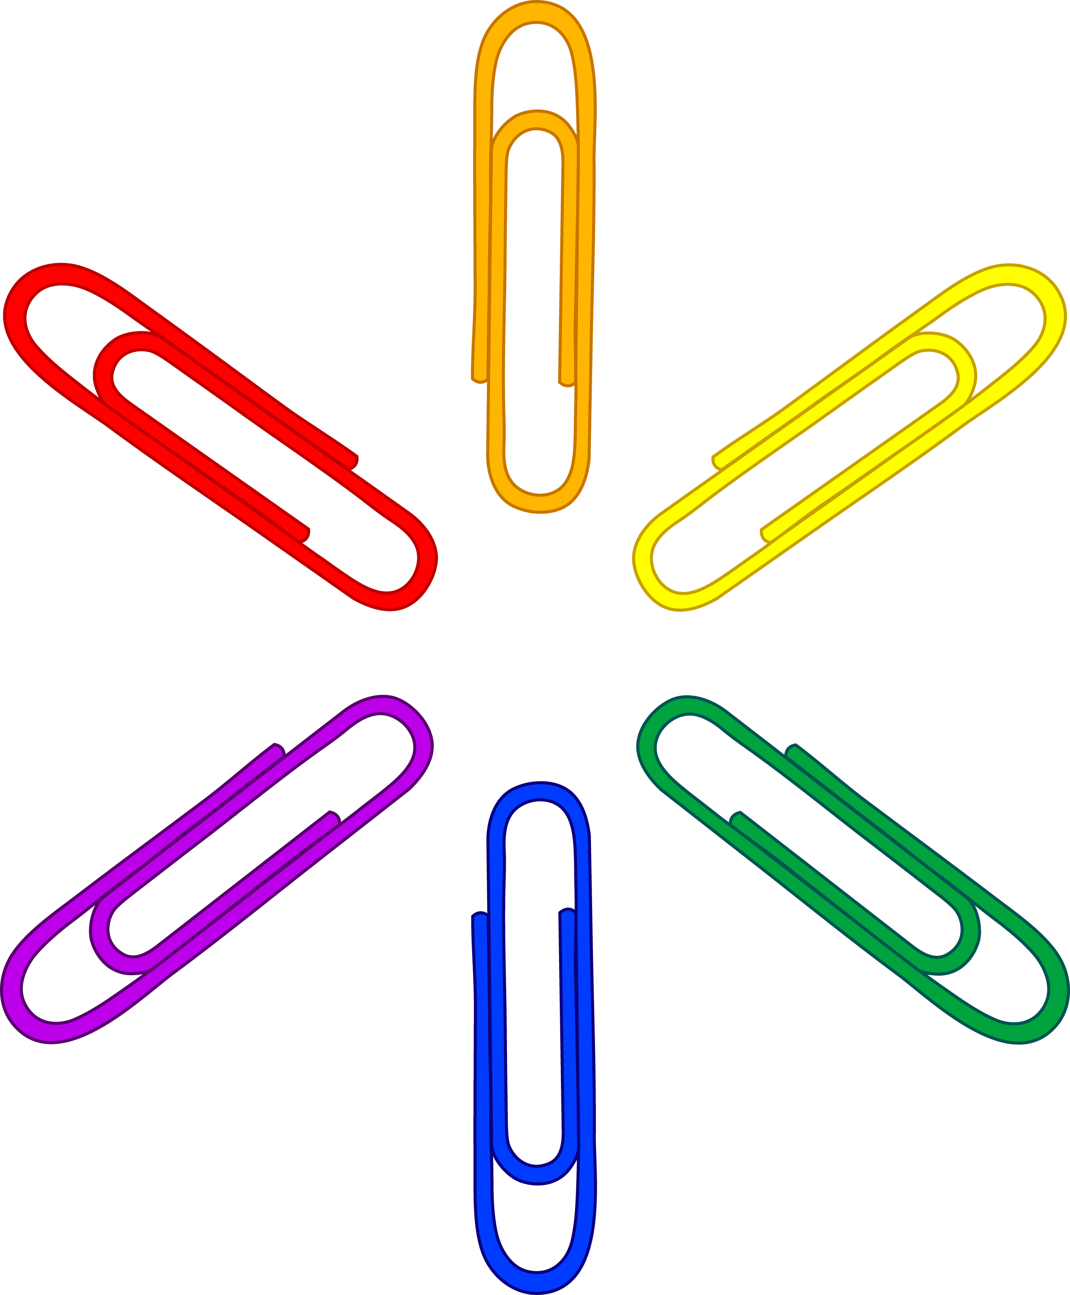](http://www.google.com/url?sa=i&rct=j&q=cartoon+picture+large+paper+clip&source=images&cd=&cad=rja&docid=NQ5gRMPUj58YAM&tbnid=htPio3oAzl_RLM:&ved=0CAUQjRw&url=http%3A%2F%2Fsweetclipart.com%2Frainbow-paper-clip-pattern-105&ei=BwqNUbDfBo6c9QTOwYCwAw&bvm=bv.46340616,d.dmQ&psig=AFQjCNFQLKSOYfnhV4JV53HtxVhPkEKjZA&ust=1368284032858897)

Every year the school office buys many boxes of large paper clips for teachers. This year the students at Friendly Elementary decided to use the paper clips for a science experiment.

* Estimate how many **large** paper clips it would take to measure 5 grams.
* Using a spring scale, how much does one **large** paper clip weigh? Using that information, how many **large** paperclips would it take to measure 5 grams?
* Russel found out that a **small** paper clip measured ½ a gram. How many **small** paper clips would it take to measure 5 grams if each one measured ½ a gram?