Name __________________­­­­_________________

Name __________________­­­­_________________

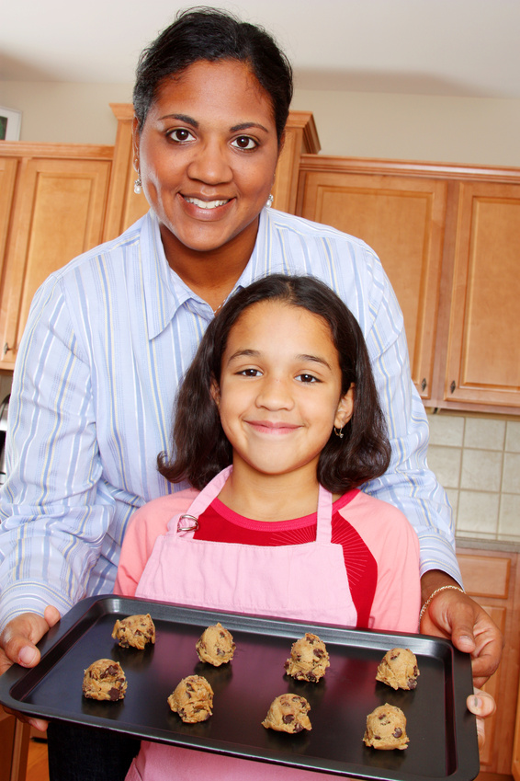

Keandra and her mom were baking cookies for the holidays. Keandra could not wait to see how the cookies tasted. This was about the tenth time she helped her mom bake cookies. Today, Keandra was surprised because her mom told her she was ready to bake the cookies all by herself. The only thing her mom was going to help her with was putting the cookies into the oven. This made Keandra feel very proud that her mom trusted her to bake by herself and a big smile spread across her face.

* Keandra knew that it would take her 20 minutes to prepare the cookies for baking. When she began it was 1:32 pm. What time would she be done preparing the cookies?
* Keandra’s mom helped put the cookies into the oven at 2:15 pm. The cookies will take 12 minutes to bake.
  + What time will the cookies be ready? Show your work below.
  + Draw the hands on the clock below to show what time the cookies will come out of the oven.

