Name __________________­­­­_________________

Name __________________­­­­_________________

C:\Documents and Settings\cscott\Local Settings\Temporary Internet Files\Content.IE5\7E19QKSI\MC900362040[1].wmf

Karen and her friends were so excited! The new movie, “The Travelling Girl,” was premiering tonight! Karen’s mom offered to take her and her friends out to eat for pizza and then to the movie. Karen wanted to make sure she got her favorite seat at the theater so she begged her mom to get to the theater extra early. Karen’s mom happily agreed.

* 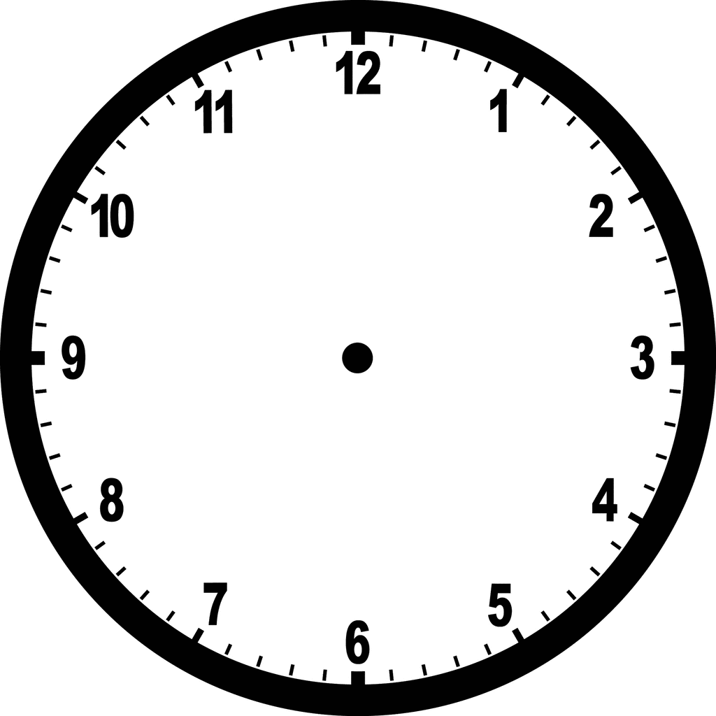Karen wanted to make sure she was at the movie theater by 6:45. When she arrived at the Pizza Palace she immediately looked at the clock. What time does the clock say?
* If Karen wants to be at the theater by 6:45, looking at the time now, how much time do the girls have before they need to be at the movie theater?