Name: ____________________

1. Nina has 4 brothers, and she gave each of them 3 toy robots. How many toy robots did she give to her brothers altogether?  Justify your solution with numbers, pictures, and/or words | 2. Carly gave each of her sisters 5 toy robots. If she gave a total of 40 toy robots, how many sisters does Carly have?  Justify your solution with numbers, pictures, and/or words.

3. Mr. Garcia gave each of his 3 children an equal number of toy robots. If he gave a total of 27 toy robots, how much did each child get?  Justify your solution with numbers, pictures, and/or words. | - Put a check mark in the box next to all the  equations that are true.  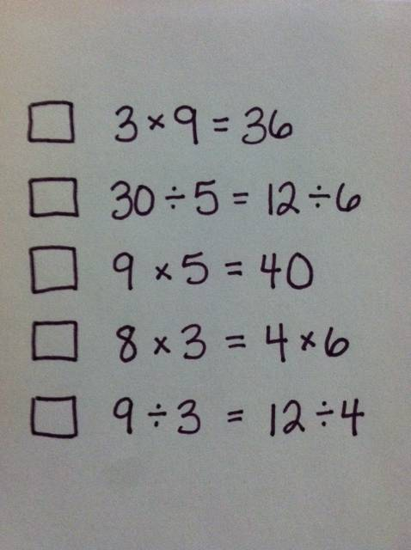

Teacher Notes:

Problems 1, 2, and 3 were adapted from the Illustrative Mathematics task “Gifts from Grandma” below is the description of the task from http://illustrativemathematics.org/illustrations/262

Standard Addressed: 3.OA.3 Use multiplication and division within 100 to solve word problems in situations involving equal groups, arrays, and measurement quantities, e.g., by using drawings and equations with a symbol for the unknown number to represent the problem.

Commentary: The first of these is a multiplication problem involving equal-sized groups. The next two reflect the two related division problems, namely, "How many groups?" and "How many in each group?"
Sometimes the second type of problem is referred to as a measurement division or repeated subtraction problem. The third type of problem is sometimes called a partitive division or sharing problem. It asks how large is each share when a whole is divided equally into a specified number of pieces. It specifies the size of each share and asks how many of that size are in the whole. The language used in the solution reflects the language in the common core, which also refers to them "Number of Groups Unknown" or "Group Size Unknown," respectively.
Problem 4 is adapted from the PARCC Sample Item to illustrate 3rd grade fluency
http://www.parcconline.org/samples/mathematics/grade-3-mathematics-fluency

Standard Addressed 3.OA.7 Fluently multiply and divide within 100, using strategies such as the relationship between multiplication and division (e.g., knowing that 8 × 5 = 40, one knows 40 ÷ 5 = 8) or properties of operations. By the end of Grade 3, know from memory all products of two one-digit numbers.

Item Description
http://www.parcconline.org/sites/parcc/files/PARCC%20Math%20Sample%20Problems_GR3FluencyV2.pdf

