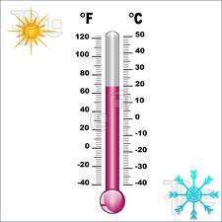 [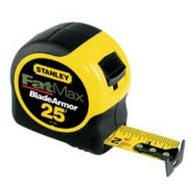](http://www.google.com/imgres?q=measuring+tape&um=1&hl=en&sa=X&rls=com.microsoft:en-us:IE-SearchBox&biw=1024&bih=616&tbas=0&tbm=isch&tbnid=ZIO5I7hhobPFcM:&imgrefurl=http://www.curbly.com/alexrussell/posts/502-stocking-the-ultimate-toolbox-every-tool-a-homeowner-will-ever-need&docid=z4TXLHKchn_tSM&imgurl=http://www.curbly.com/uploads/photos/0000/0001/1412/measuring_tape_large.jpg&w=664&h=664&ei=JdzCTr2QHa3_sQKejInOCw&zoom=1) [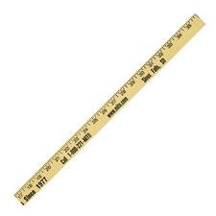](http://www.google.com/imgres?q=yard+stick&um=1&hl=en&rls=com.microsoft:en-us:IE-SearchBox&biw=1024&bih=616&tbm=isch&tbnid=83MQHjtNoWt4SM:&imgrefurl=http://www.fjcruiserforums.com/forums/off-topic-discussion/85011-i-got-kicked-out-cub-scouts-funny.html&docid=EbY-Ee_acbqwxM&imgurl=http://i113.photobucket.com/albums/n225/felony76/Yardstick.jpg&w=288&h=288&ei=TNzCTtOuFa-asgL87P3-Cg&zoom=1)

Therometer Tape Measure Yard Stick

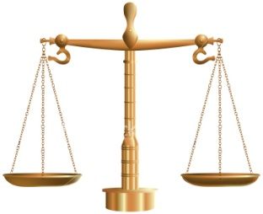 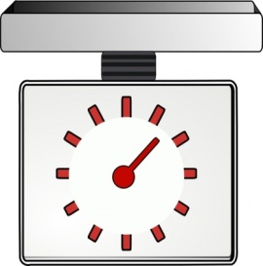 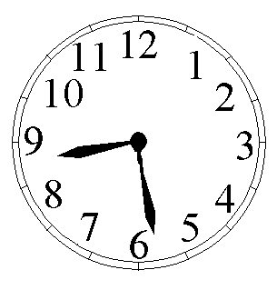

Balance Scale Food Scale Clock

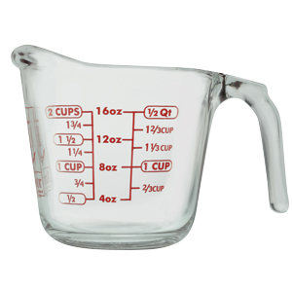 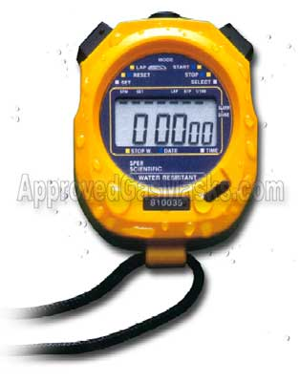 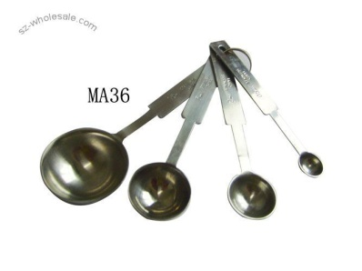

Measuring Cup Stop Watch Teaspoons

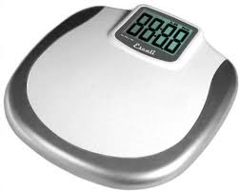 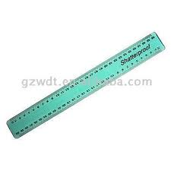 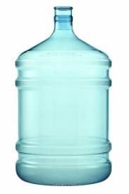

Scale Ruler Gallon