**1**

**Part A**

What does **cross** mean as it is used in paragraph 28 of “Johnny Chuck Finds the Best Thing in the World”?

* A. excited
* B. lost
* C. upset
* D. scared

**Part B**

Which statement **best** supports the answer to Part A?

* A. “. . . ran this way and ran that way . . .”
* B. “. . . hadn’t found the Best Thing in the World.”
* C. “. . . they started up the Lone Little Path . . . .”
* D. “They didn’t hurry now . . . .”

### 2

### Part A

How do the details in the story show the idea of “Con-tent-ment”?

* A. through describing what Johnny Chuck does at his home
* B. through the question that Johnny Chuck asks in the story
* C. through the explanation of the animals’ hunger after their search
* D. through the listing of all the animals that join the group

### Part B

Which detail from “Johnny Chuck Finds the Best Thing in the World” supports the answer to Part A?

* A. “By and by they all came to the house of Johnny Chuck.”
* B. “. . . played all day among the flowers with the Merry Little Breezes of Old Mother West Wind . . .”
* C. “. . . Striped Chipmunk and Peter Rabbit and Bobby Racoon and Jimmy Skunk and Reddy Fox ran this way and ran that way over the Green Meadows trying to find the Best Thing in the World.”
* D. “Peter Rabbit hadn’t found so much as the leaf of a cabbage.”

3

Complete the chart to show how the animals searching for the best thing in the world are described up to paragraph 21. Drag and drop **three** details into the chart.

**Details to Describe the Animals**

* **want more than what they have**
* **play among the flowers**
* **run along the path looking for their favorite things**
* **enjoy warm sunshine and beautiful sky**
* **are eager to find something**
* **like listening to stories**

|  |
| --- |
| **Details to Describe the Animals** |
|  |
|  |
|  |

4

**Part A**

What does the phrase **his teeth jiggled** in paragraph 14 show about Pinkerton?

* A. Pinkerton feels pain.
* B. Pinkerton feels tired.
* C. Pinkerton feels excited.
* D. Pinkerton feels nervous.

**Part B**

Which detail from “Me First” shows another example of the answer to Part A?

* A. “Soon he heard the voice again, closer and louder this time.”
* B. “His imagination almost burst.”
* C. “He landed face to face with a small creature. . . .”
* D. “Pinkerton waited. One second. Two seconds.”

5

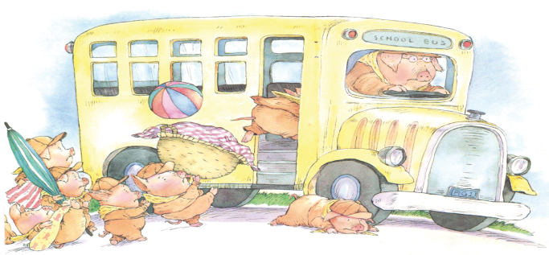**Part A**

Select one sentence from this drop-down menu that describes what is happening in this picture. Then, select one sentence from the next drop-down menu that describes what the picture adds to the story.

**What is Happening?**   
         
  
**What the Picture Adds**   
       

**Part B**

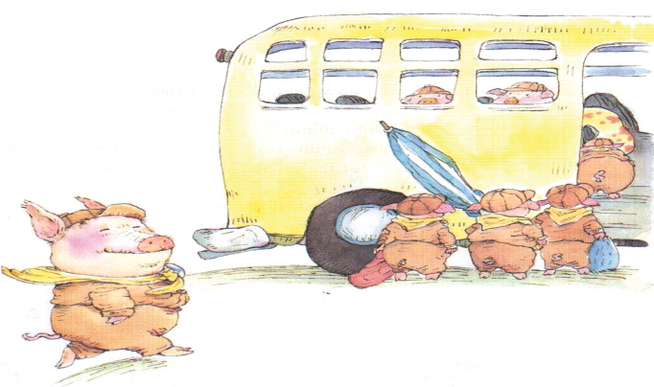

Select one sentence from this drop-down menu that describes what is happening in this picture. Then, select one sentence from the next drop-down menu that describes what the picture adds to the story.

**What is Happening?**   
         
  
**What the Picture Adds**

**What the Picture Adds**   
       

6

**Part A**

How do Pinkerton’s actions lead him to be tricked by the Sandwitch?

* A. Pinkerton thinks only about himself, so he keeps the Scouts from meeting the Sandwitch.
* B. Pinkerton cares more about eating than helping his fellow Scouts, so he keeps the Sandwitch a secret.
* C. Pinkerton wants to be better than the other Scouts, so he volunteers to help the Sandwitch.
* D. Pinkerton wants to arrive before everyone, so he runs ahead of the Scouts toward the sound of the Sandwitch's voice.

**Part B**

Which detail from “Me First” supports the answer to Part A?

* A. “Pinkerton was first on the bus and sat in the front row.”
* B. “As the Pig Scouts marched across the sand, they heard a faint voice far in the distance.”
* C. “‘ME FIRST!’ cried Pinkerton, kicking up sand and leaving the other Pig Scouts far behind.”
* D. “A slab of cheese! A blob of mayo! A smear of mustard. All for ME! FIRST!”

7

Old Mother West Wind and the Sandwitch both try to teach important lessons to characters in the stories.

Write an essay that explains how Old Mother West Wind’s and the Sandwitch’s words and actions are important to the plots of the stories. Use what you learned about the characters to support your essay.

**8**

**Part A**

Read paragraph 14 from the story.

Maybe the cola was warm, or maybe it had been jostled too much, because when Dad opened it, that bottle erupted like Mount Vesuvius. Cola overflowed like lava. Dad dropped the bottle. It rolled across the tent floor spewing its contents, and we ended up perched on our sleeping bags like castaways adrift in a cola sea.

What does **that bottle erupted like Mount Vesuvius** mean as used in the paragraph?

* A. The cola bottle was open and floating in the water.
* B. The cola was bubbling and spilling out.
* C. The cola bottle was moving around.
* D. The cola was hot.

**Part B**

Which detail from the paragraph supports the answer to Part A?

* A. “. . . the cola was warm . . . .”
* B. “. . . jostled too much . . .”
* C. “. . . overflowed like lava.”
* D. “. . . perched on our sleeping bags . . .”

9

**Part A**

Read the sentence from paragraph 15 of the story.

Derrick clapped both hands over his mouth.

Why does Derrick cover his mouth with his hands?

* A. He does not want to show his feelings.
* B. He is making an angry face.
* C. He is covering a sneeze.
* D. He does not feel well.

**Part B**

Which detail from paragraph 15 **best** supports the answer to Part A?

* A. “His face turned red. . . .”
* B. “. . . his cheeks ballooned out . . . .”
* C. “From behind his hands . . .”
* D. “. . . snorting of trapped laughter.”

10

**Part A**

Derrick and the narrator start to make fish faces. How does this affect what happens next in the story?

* A. It helps Dad feel better, and he joins in.
* B. It upsets Dad, and the boat almost sinks.
* C. It surprises Dad, and he lets go of the motor.
* D. It leads Dad to a solution, and they catch fish.

**Part B**

Choose **two** details from paragraphs 28 through 33 that support the answer to Part A.

* A. “. . . his favorite fish, the largemouth bass.”
* B. “‘Fishy, fishy, bite my hook,’ he chanted. . . .”
* C. “Dad’s bass frown upturned into a grin.”
* D. “. . . the boat started sinking.”
* E. “‘. . . should there be this much water in your boat?’”
* F.“We barely reached shore. . . .”

11

Drag and drop into the chart the way that Dad responds to each event during the camping trip. Not every response will be used.

**How Dad Responds**

* **Dad feels sad that the trip was not a success.**
* **Dad hurries the boys into the tent.**
* **Dad gets everyone to work together to make it safely back to shore.**
* **Dad talks about how much fun it is to catch fish.**
* **Dad starts to feel happier.**

|  |  |
| --- | --- |
| **Events** | **How Dad Responds** |
| Derrick asks if it is snowing. |  |
| The boys make fish faces. |  |
| Derrick asks if there should be water in the boat. |  |

12

**Part A**

What is a central message of the story?

* A. People may be surprised by the weather.
* B. People can be happy even when things go wrong.
* C. Sometimes it is easy to prepare for new things.
* D. Something that is here today may be gone soon.

**Part B**

Which sentence from the story supports the answer to Part A?

* A. “There was a stiff, icy breeze blowing off the lake.”
* B. “‘The snow should be gone tomorrow.’”
* C. “‘We’re glad you came.’”
* D. “As for Dad, he smiled a brave smile.”

13

This story tells about Derrick’s first camping trip.

Write Derrick’s journal entry about this camping trip. Include information about how the characters responded to the events in the story as you write the journal entry.