Overview of the Unit
Goals of the Unit:
- Researchers locate and use information
- Researchers organize ideas to teach what they know
1.  Using multiple sources  I can find information in different places. | 2.  Important words and phrases  I can identify important words about my topic. | 3.  Finding facts in pictures  I can learn new information from pictures. | 4.  Text features: Labeled diagrams  I can use labels to help me understand more about ______. | 5.  Note taking Strategy: I remember  I can remember and retell the important information.
6.  Fact and opinion  I can write about my research using facts. | 7.  Creating question and answer books  I can write a question and answer book. | 8.  Asking questions  I can ask good questions. | 9.  Draw before you write  I can sketch my pictures first to help me think about the words to write. | 10.  Bold words
11. Numbering the pages | 12. Making a table of contents  Very guided- compile all pages we wrote about symbols and create a table of contents (at end) pp. 216-217
About this unit:
This unit was created to introduce kindergarteners to research and the language and tasks associated with it. Depending on your content focus it may be more teacher guided than other workshop units. The goal of this unit is to expose students to ways researchers gather factual information as they:
- Explore the world around them
- Reflect on learning
- Separate fact from opinion
- Think about how to share ideas
The ELA standards have been identified but the Social Studies/Science standards will vary depending on the topic/area you are studying. Most of the lessons have been adapted from the text Crafting Nonfiction: Lessons on Writing Process, Traits, and Craft (Primary) by Linda Hoyt.
Suggested Mentor Texts
In addition to content area texts that will provide the information you are learning about you may also need:
Text | Author | Information
Who Hops | Katie Davis | These simple books are written in the format of Question and Answer and can be used to introduce this text type.
Who Hoots | Katie Davis

TROUBLE SHOOTING
The following lessons may be needed to troubleshoot and maintain your workshop. They can be included as mini lessons, mid-workshop teaching points, individual or small group conferences, or end-of-the-workshop shares.

If your students are having trouble with this… | You might try this mini lesson

Part One: The Work of Researchers
Goal(s): 1. Locate and use information

Session 1 Using Multiple Sources
Goal: I can find information in different places.  Standards: W.K.7 (shared research), W.K.8 (recall/gather information) |  | About this lesson: This lesson introduces students to the world of research. They will encounter new domain specific words like research, source, nonfiction, topic, facts. This lesson will be mostly teacher guided/whole group.
Anchor Charts:  TChart (sort of)  Alike/Different | CONNECTION (G, A): Writers of nonfiction need to use lots of different sources for their information. This way we can make sure we have the very best facts about our topic. Today I want to teach you how researchers can use multiple (or many) resources to find all the information about our topics. |  | Conferring and Small Group  You may need to work with a small group to complete this task through guided writing.
Texts:  you tube: flag  Multiple texts about the topic | TEACHING and ACTIVE ENGAGEMENT(N,A): Today I am going to share some information with you about _______. We are going to learn about this topic from several different sources. We are going to pay attention to the kinds of information we are learning: some things we will hear the same in each source. Sometimes we’ll read a new fact that we don’t already know. Let’s read and listen for the information that we hear that is the same and different from each of the sources.  Let’s look and listen to some of these different sources about ________. We want to listen for information that is the same in all three sources. We also want to listen for new facts. (as you read, stop and think aloud as you encounter same and new facts).  After reading/viewing you can develop a chart together identifying information that you learned that was the same and different.
Resources:
Reading Notebook:
Write something you learned that was the same in all three sources.
Differentiate: Divide your page in half and on one side write the fact that was in all three. On the other side write something that was only in one of the texts.

Adapted from Crafting Non-fiction pp.48-49
 | LINK: SO remember that when we are researching a topic we want to use more than one resource so that we can be sure to get the very best facts for our research.
 | TEACHING SHARE:.This would be a good time to reiterate that for researchers, sources are more than just books. You may even begin a chart: Sources for Research (books, videos… and add on when you encounter new things)
Session 2 Important words and phrases
Goal: I can identify important words about my topic.  Standards: L.K.6 domain specific, RI.K.4, W.K.2 |  | About this lesson: This lesson focuses on the domain specific language students will need to become familiar with in order to read and write about their topics. Words (and visuals when possible) that are important to the topic can be added to the Alpha Box. This word wall/word collection should be in addition to the word wall you use for high frequency words. Teachers may choose to keep one large alpha box for the class and others may decide to provide copies for the students as well.
Anchor Charts:  Alpha box/ content word wall-  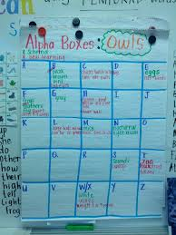  You may want to use a different color marker for each of the national symbol words: red for flag words, blue for liberty bell, etc. | CONNECTION (G, A): Yesterday we talked about how important it is for researchers to locate information in multiple sources. T/T about what we mean when we say “multiple sources..” What are some examples? (books, videos, magazines). Today I want to teach you that researchers need to pay attention to the words in those sources that are important to know about our topic. |  | Conferring and Small Group
Texts:  Text from lesson  New text/new topic | TEACHING and ACTIVE ENGAGEMENT (N, A): Watch as I read, listening carefully for words that are important about our topic. Read aloud and pause after a page or two, thinking aloud words that are important to understand the content and add them to your alpha box. (if you know in advance which words you will be adding, you can have an image prepared as well that will help students read the word). For an example of how the think aloud could go, see page 46.  Did you notice that I only wrote the really important words about our topic.  Now watch how these words can help me write about _______. Model writing a few sentences about your topic using words from the Alphabox.  Now it’s your turn. I am going to read about a new topic: _______ I want you to put up a finger if you hear a word you think we should add to the alphabox. Read and then pause so students can turn and talk about which words to add. Share and add. Continue reading, T/T, add words.  OK now how could I use these words to write about ____. T/T about something you could write about ___ using words from our Alphabox. You may want to share a few different examples aloud.
Resources:
Adapted from Crafting Non-fiction pp.46-47
 | LINK: When we write, I would like you to use our alphabox to help you write your research about ___________.
 | TEACHING SHARE: Share some exemplar pieces. Perhaps also share some average pieces and discuss how we could make them even better.

Session 3 Finding facts in pictures
Goal: I can learn new information from pictures.  Standards: W.K.7, W.K.8, RI.K.7 |  | About this lesson:  This lesson draws attention to the charts, illustrations, diagrams, and other visuals that are essential to non-fiction texts. Writers need to attend closely to these in order to understand that important information can be found from these sources.
Anchor Charts:  Prepare in advance- can be added to throughout the unit/year  What are visuals?  Labeled images of visuals kindergartners may encounter in their texts. | CONNECTION (G, A): So far we have focused on the important words and information found in our sources. We wrote these words in our Alphabox so we could use them to write about our research. T/T to your partner about some of the important words we added to our Alphabox yesterday. Today I want to teach you that books aren’t the only place we can learn new words and information. We can also learn a lot from the visuals in our texts. |  | Conferring and Small Group
Texts:  Any enlarged text with a variety of visual images. THIS DOES NOT HAVE TO BE CONTENT RELATED for the Teach.  Visual images (related to your topic hopefully) that students can observe and describe. | TEACHING(N): Look at this page. Show me the words on the page. We get lots of information on our topic from the words. But there are also visuals on the page. Who thinks they can find a visual? Invite students to come up and identify the pictures, diagrams, etc. Share a chart that shows examples of a variety of visuals that are labeled.  Visuals are very important for researchers. They often tell us more about our topic or help us understand it better. Let’s look at this photograph* of ____. A photograph* is one kind of visual researchers use.  Listen in as I study the visual on this page. Think aloud as you describe what you see in the visual. Make it clear that you are getting information from the picture even if there aren't any words. If you are going to engage students in work with the same visual, limit your thinking so that they will have enough information to notice/discuss. You will likely need to add words to your Alphabox based on the visual. (For an example of a think aloud see p. 44 of Crafting Nonfiction)  *or any visual
Resources:  Readers Notebook:  Write  Adapted from Crafting Non-fiction pp.48-49 | ACTIVE ENGAGEMENT(A) Now it’s your turn. Let’s look at this visual and describe what we see. Partner A describe something you see to Partner B. Partner B, be a good listener because you’ll be studying the visual and adding something new that describes it. Continue sharing observations about the visual. Add to the alphabox as needed.
 | LINK: Today I want you to think about everything we’ve learned about _____. Let’s use that information to write about ______. (ex: write sentences to describe the Statue of Liberty based on what you observed from the photograph).
 | TEACHING SHARE: select several students to display their notebooks on the document camera and describe what they observed in their visual images.

Session 4 Text features: Labeled diagrams
Goal: I can use labels to help me understand more about ______.  Standards: RI.K.7, RF.K.3.a., W.K.2 |  | About this lesson:  Labels on photos and illustrations draw attention to content vocabulary. Non fiction writers need to learn how to use labels as researchers and writers.
Anchor Charts:  Refer to previous chart What are visuals?  from Lesson 3 | CONNECTION (G, A):. We have just learned that nonfiction texts contain many different kinds of visuals. Point to the chart as a reference and ask students to T/T to recall some of the visuals you talked about previously and included on your anchor chart. Today I want to teach you that labels are important tools because they help us focus on the important words. |  | Conferring and Small Group
Texts:  If you have a PDF of the American flag you can open ___ in Launchy and students can label the flag on the smart board. | TEACHING and ACTIVE ENGAGEMENT(N, A): As I look at this picture of the American flag, I realize that I can be an even better researcher if I place labels right on my illustrations- like we did when we were first learning to write. Labels can help me think about the important words I need to collect to learn everything I need to know about the flag. Let’s work together to label this photo/illustration of the American flag. T/T about what we can label on the flag (red, white, blue, stars, stripes) that will help us think about the important words we need to know about the flag. Using interactive writing (sharing the pen) work together with students to label the parts of the flag. This can be done
Resources:  Large sticky notes for labels unless using the smart board.  (optional) white boards and markers for students to participate in the interactive writing | LINK: Today I would like you to take out the writing you did yesterday and think about the important parts of the illustration you made of the Statue of Liberty. What are some of the parts of the illustration that you might label? Where might we find the words we need to label the illustration? Allow time for students to add labels. Those that finish early can make their own labeled illustration of the flag and a written description. So today, and whenever we are researching information writing, remember to look for and use labels to help understand the information better.
TEACHING SHARE:
Share some of the labeled illustrations students complete.

Session 5 Note taking Strategy: I remember
Goal: I can remember and retell the important information.  Standards: W.K.8, SL.K.4, SL.K.5 |  | About this lesson:  The goal of this lesson is to help young researchers retain information in order to write about it. By pausing to think about small amounts of information, they remember more.
Anchor Charts: | CONNECTION (G, A): It's very important for researchers to remember what we are reading. Today I want to teach you how researchers can read and remember the important parts of the text. |  | Conferring and Small Group  If you have students still struggling to transfer their ideas to writing, you may decide to complete a shared or guided writing piece, scaffolding the strategy with additional support.
Texts:  New text or topic | TEACHING(N): As researchers we need to think about what we read then retell it so we know what to write. Watch me as I read and remember. Using a new text, model for students how researchers read a bit then pause and retell what they've read beginning with, “I remember...” Did you notice that I just read a little bit then I retold what I read starting with “I remember” ? That will help me when I am writing about what I am learning.
Resources:  Student note-taking page, I remember (read and recall 3 facts using jot dots, label the topic, and illustrate)  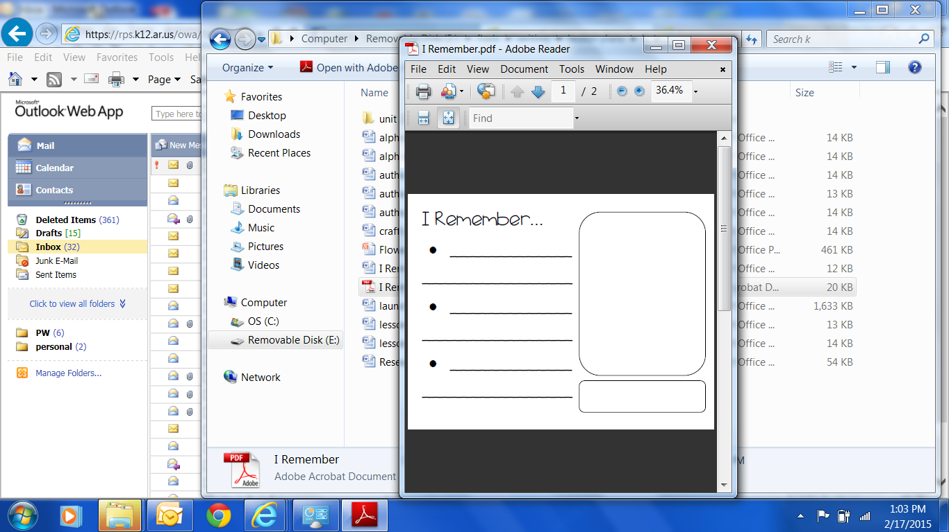  Adapted from Crafting Non-fiction pp.54-55 | ACTIVE ENGAGEMENT(A)Now it's your turn. I am going to read and partner A, when I stop you will turn to partner B and retell what you've learned beginning with “I Remember....” Then we'll give partner B turn. You will listen and retell the important information you remember.  GUIDED WRITING: Reread the same information, pausing to let partners tell what they remember. Then working in pairs, provide opportunities for each child to listen, remember, and write.
 | LINK: From now on, when you are researching a new topic, remember to use this strategy to help you remember
 | TEACHING SHARE: Allow opportunities for students to share what they learned about the new topic.

Session 6 Fact and opinion
Goal: I can write about my research using facts.  Standards: |  | About this lesson: This lesson teaches students that researchers must recognize when we are reading and writing true facts or just what we or someone thinks about a topic.
Anchor Charts:  Fact or Opinion?  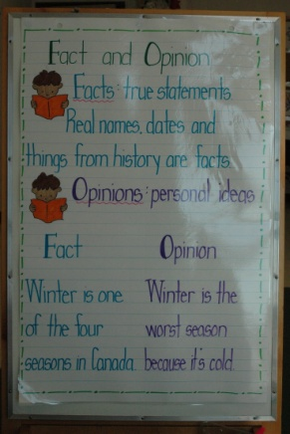  This is an example of a very simple comparison of fact and fiction. | CONNECTION (G, A): (refer to the new information/topic from the previous day) |  | Conferring and Small Group
Texts:  Introduce a new topic/text | TEACHING(N):
Resources:  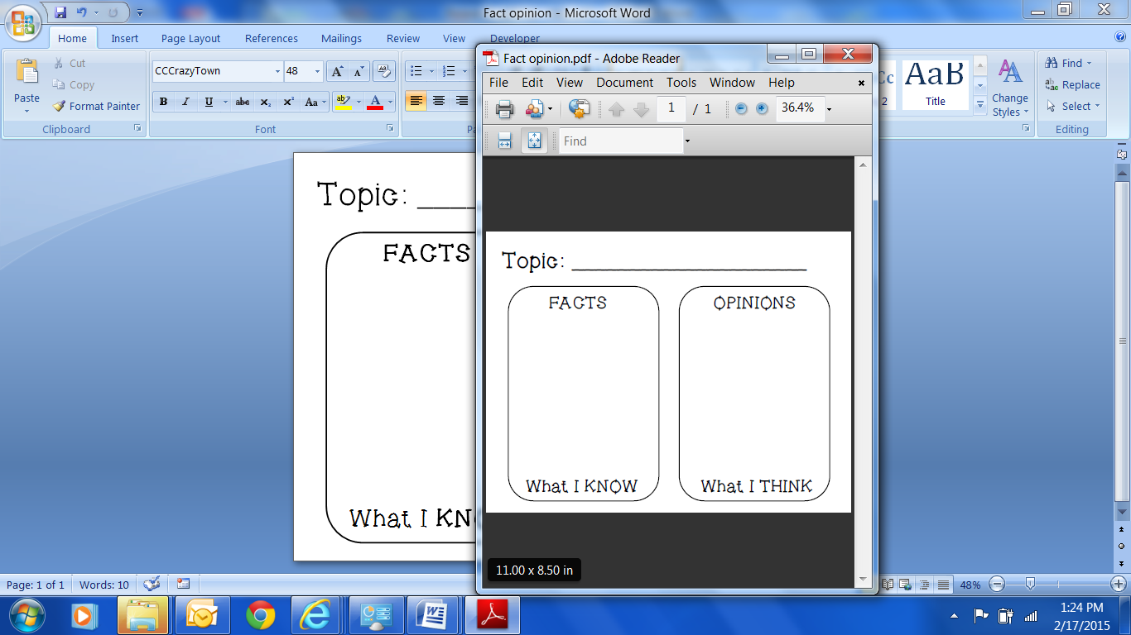  Adapted from Crafting Non-fiction 168-169 | ACTIVE ENGAGEMENT(A)
 | LINK:
 | TEACHING SHARE:

Part Two: Researchers Organize Ideas to Teach What They Know
Goal(s): 1. Understand the format of question and answer books 2. Revise and publish a book about the topic they have been studying using question and answer format

Session 7 Creating question and answer books
Goal: I can write a question and answer book.  Standards: W.K.2, W.K.8 |  | About this lesson: When non fiction writers have opportunities to create and record questions on topics of interest, they become more invested in their topics and the groundwork is laid for ongoing research. This lesson will introduce writers to the question and answer format and will provide a template for sharing their knowledge about the topic they have been studying/researching. The lessons that follow this one will all contribute to their final Question and Answer book.
Anchor Charts: | CONNECTION (G, A): |  | Conferring and Small Group
Texts:  Who Hoots by Katie Davis  Who Hops by Katie Davis | TEACHING and ACTIVE ENGAGEMENT(G, A):  When we organize a book around questions it helps us keep our ideas clear and organized.
Resources:
Paper formatted for creating a question and answer book

Adapted from Crafting Non-fiction pp.198-199
LINK: So whenever we decide to write a question and answer book, we start with a good question on one page and we answer that question, with just the facts, on the next page so the book forms a pattern: question, answer, question, answer…
Let’s start it together. Let students help you create a question about the first topic in your book. They will write that question on the first page of their books. Then discuss together how you might answer the question in 2 or more sentences that are facts. Allow students to work independently on the answer page and illustrate their work. You can also remind them to add labels to their illustrations.
 | TEACHING SHARE:.Share some of the questions and answers students developed about their first topic.

Session 8 Asking questions
Goal: I can ask good questions.  Standards: RI.K.1, RI.K.10, W.K.2, W.K.8 |  | About this lesson: This initial lesson is was written using a class topic and whole group reading/research. The format may vary if students are working in groups or doing independent research.
Anchor Charts:  Topic Checklist  This chart may look like a checklist. You will include the class topic and the subtopics so that during the following lessons, students are sure to include each subtopic.  Good questions  You will also want to generate a list of sentence stems to give students some variety/choice in how they ask the questions:  - What is the…  - Why is ____ important?  - Do you know about ____? | CONNECTION (G, A): Yesterday we began our question and answer books about _____. The first question we asked together was about _____. T/T about the other (national symbols/animals/community helpers/etc.) that we can write about in our Q and A books. Make a chart listing the other subtopics that students may include. Today I want to teach you that some questions are better than other questions. |  | Conferring and Small Group  Some students may need additional guidance as they create each question and answer page. Be sure to check in with these students daily so they can say their question and answer orally before writing.
 | TEACHING(N):
Texts:

Resources:  Adapted from Crafting Non-fiction | ACTIVE ENGAGEMENT(A
 | LINK:
 | TEACHING SHARE:.Mini mini lesson: Remember writers that all sentences begin with ____. And they all end with ____. Let’s meet with our partners to look at the work we’ve done so far. We want to make sure every question we ask ends with a question mark and every answer ends with a period. Then we want to check each sentence to make sure we begin it with a capital letter.

Session 9 Draw before you write
Goal: I can sketch my pictures first to help me think about the words to write.  Standards: |  | About this lesson:
Anchor Charts: | CONNECTION (G, A): |  | Conferring and Small Group
Texts: | TEACHING(N):
Resources:  Adapted from Crafting Non-fiction pp. 66-67 | ACTIVE ENGAGEMENT(A
 | LINK:
 | TEACHING SHARE:.

Session 10 Using bold words
Goal: Standards: |  | About this lesson:
Anchor Charts: | CONNECTION (G, A): |  | Conferring and Small Group
Texts: | TEACHING(N):
Resources:  Adapted from Crafting Non-fiction pp. 214-215 | ACTIVE ENGAGEMENT(A
 | LINK:
 | TEACHING SHARE:. Mini mini lesson- One way to make sure that the words we write match what we are trying to say is to count the words in the sentence. So if when I decide what to write I can say it and repeat then count the number of words. After I read it back and touch each word I can make sure I included every word that needs to be there. Think aloud as you model this process.

Session 11 Number the pages
Goal: I can organize my book for others to read.  Standards: |  | About this lesson:
Anchor Charts: | CONNECTION (G, A): |  | Conferring and Small Group
Texts:  Two texts: informational (with page #s) and literature (without page #s) | TEACHING(N):
Resources:  Adapted from Crafting Non-fiction pp. 218-219 | ACTIVE ENGAGEMENT(A
 | LINK:
 | TEACHING SHARE:

Session 12 Making a table of contents
Goal: I can organize my book for others to read.  Standards: |  | About this lesson:
Anchor Charts: | CONNECTION (G, A): |  | Conferring and Small Group
Texts: | TEACHING(N):
Resources:  Adapted from Crafting Non-fiction pp. 216-217 | ACTIVE ENGAGEMENT(A
 | LINK:
 | TEACHING SHARE:.
Session 13 Interesting titles and creative covers
Goal:  Standards: |  | About this lesson:
Anchor Charts: | CONNECTION (G, A): |  | Conferring and Small Group
Texts: | TEACHING(N):
Resources:  Adapted from Crafting Non-fiction pp. 204-205 | ACTIVE ENGAGEMENT(A
 | LINK:
 | TEACHING SHARE:.

Session 1 Getting ready to read
Goal  Standards: |  | About this lesson:
Anchor Charts: | CONNECTION (G, A): |  | Conferring and Small Group
Texts: | TEACHING(N):
Resources: | ACTIVE ENGAGEMENT(A
 | LINK:
 | TEACHING SHARE:.

