Kate hugged her mother, and they wept for the

sorrow and wonder of it all.

Then they climbed into the chariot and rose

through the clouds, to the castle that was once

again theirs…

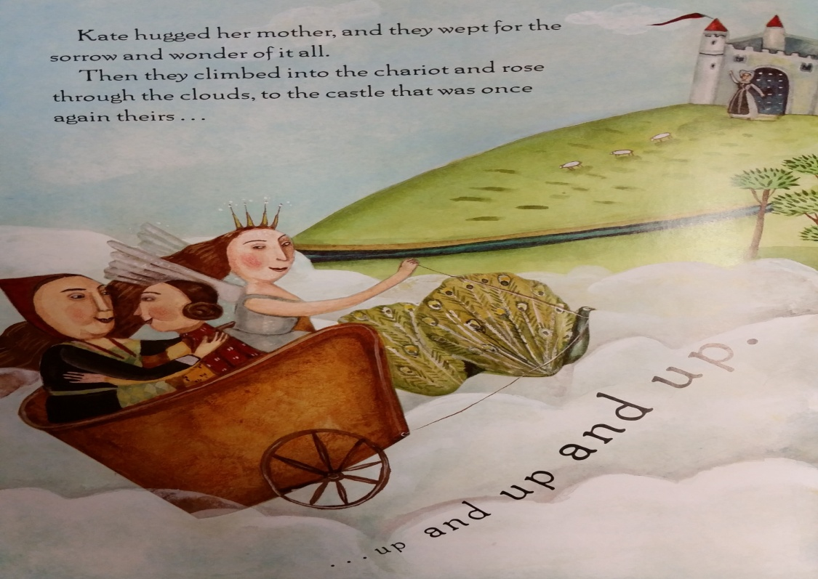

Use what you know about Kate to write a new ending to the story.

_______________

_______________

_______________

_______________

_______________

_______________