Name_____________________________________________________

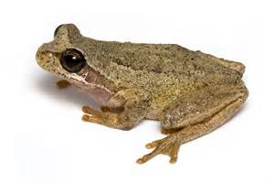

Life Cycle of a Frog

**First,**

[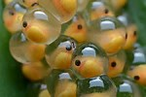](http://www.bing.com/images/search?q=frog+eggs+pictures&id=D833D44CADEE343071E55479B5F580DA1BD85B0D&FORM=IQFRBA)

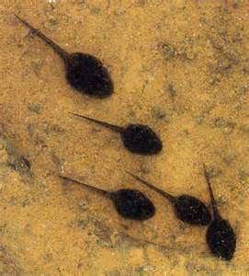

**Next,**

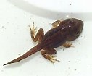

**Then,**



**Last,**