Name_____________________________________________________

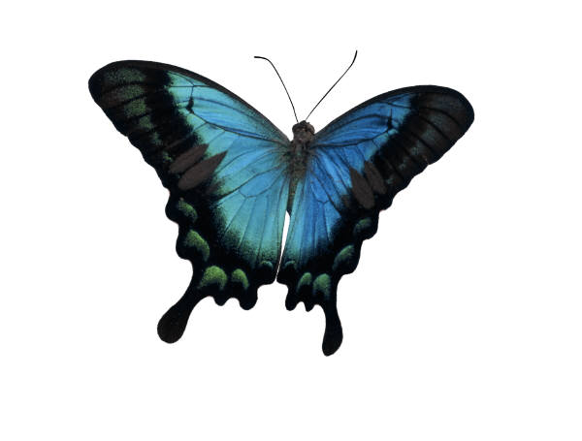

Life Cycle of a Butterfly

**First,**

[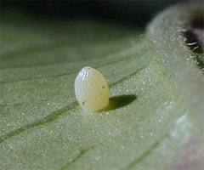](http://www.google.com/imgres?q=caterpillar+eggs&um=1&hl=en&rls=com.microsoft:en-us:IE-SearchBox&biw=1024&bih=616&tbm=isch&tbnid=4jDxEYMbjB8dJM:&imgrefurl=http://ed101.bu.edu/StudentDoc/current/ED101sp09/alyssdam/egg.html&docid=4kYEUA5rYVuIJM&imgurl=http://ed101.bu.edu/StudentDoc/current/ED101sp09/alyssdam/Butterfly-Egg.jpg&w=300&h=250&ei=91N_T8GxIoSs2wXT7PHpBg&zoom=1&iact=hc&vpx=464&vpy=166&dur=78&hovh=200&hovw=240&tx=131&ty=109&sig=109887788055049096727&page=1&tbnh=119&tbnw=172&start=0&ndsp=15&ved=1t:429,r:12,s:0,i:159)

[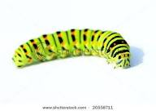](http://www.google.com/imgres?q=green+caterpillars&start=98&um=1&hl=en&rls=com.microsoft:en-us:IE-SearchBox&biw=1024&bih=616&tbm=isch&tbnid=dZeCxg68CYzxYM:&imgrefurl=http://www.shutterstock.com/pic-20558711/stock-photo-green-caterpillar-on-white-background.html&docid=Uyg3yaweboKnfM&imgurl=http://image.shutterstock.com/display_pic_with_logo/175351/175351,1226764598,1/stock-photo-green-caterpillar-on-white-background-20558711.jpg&w=450&h=319&ei=G1h_T5T0F4XS2AXlpMSHBw&zoom=1&iact=rc&dur=0&sig=109887788055049096727&page=6&tbnh=116&tbnw=163&ndsp=20&ved=1t:429,r:32,s:98,i:31&tx=33&ty=99)

**Next,**

[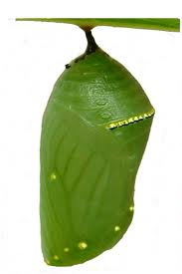](http://www.google.com/imgres?q=chrysalis&um=1&hl=en&rls=com.microsoft:en-us:IE-SearchBox&biw=1024&bih=616&tbm=isch&tbnid=bezHDXSnYn69OM:&imgrefurl=http://www.obsessionwithbutterflies.com/owb_chrysalis.html&docid=yQMLB7_iMW1NiM&imgurl=http://www.obsessionwithbutterflies.com/img/butterfly/Monarch%20Chrysalis2.jpg&w=300&h=450&ei=LFl_T7r0EYim8ASL973ABw&zoom=1&iact=hc&vpx=210&vpy=2&dur=1516&hovh=275&hovw=183&tx=95&ty=97&sig=109887788055049096727&page=1&tbnh=115&tbnw=79&start=0&ndsp=22&ved=1t:429,r:1,s:0,i:135)

**Then,**

**Last,**

[](http://www.google.com/imgres?q=butterflies&um=1&hl=en&rls=com.microsoft:en-us:IE-SearchBox&biw=1024&bih=616&tbm=isch&tbnid=-XWymBiLDrxc2M:&imgrefurl=http://www.butterflypictures.net/&docid=-PcR8ZrLwECyjM&imgurl=http://www.butterflypictures.net/images/Buttefly1.gif&w=400&h=400&ei=pVp_T6_6Coma8gTis-zRBw&zoom=1&iact=hc&vpx=236&vpy=155&dur=156&hovh=225&hovw=225&tx=110&ty=118&sig=109887788055049096727&page=1&tbnh=118&tbnw=122&start=0&ndsp=18&ved=1t:429,r:1,s:0,i:135)