**Two Tree Toads**

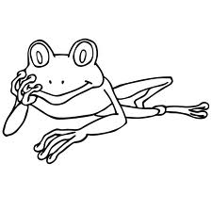

**By Jon Agee**

**A three-toed tree toad tried to tie**

**A two-toed tree toad’s shoe.**

**But tying two-toed shoes is hard**

**For three-toed toads to do,**

**Since three-toed shoes each have three toes,**

**And two-toed shoes have two.**

**“Please tie my two-toed tree toad shoe!”**

**The two-toed tree toad cried.**

**“I tried my best. Now I must go,”**

**The three-toed tree toad sighed.**

**The two-toed tree toad’s two-toed shoe,**

**Alas, remained untied.**

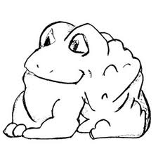

Little Black Bug

Little black bug,   
Little black bug   
Where have you been?   
I've been under the rug,   
Said little black bug.   
*Bug-ug-ug-ug.*

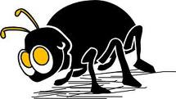

Little green fly,   
Little green fly,   
Where have you been?   
I've been way up high,   
Said little green fly.   
*Bzzzzzzzzzzzzzzzzzz.*

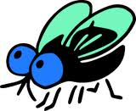

Little old mouse,    
Little old mouse,   
Where have you been?   
I've been all through the house   
Said little old mouse.   
*Squeak-eak-eak-eak-eak.*

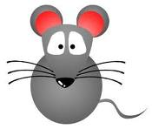

By Margaret Wise Brown

|  |  |  |
| --- | --- | --- |
|  |  |  |
|  |
|  |
|  |

Caterpillar

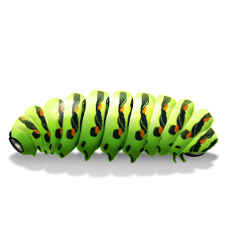

By Christina Rossetti

Brown and furry  
Caterpillar in a hurry,  
Take your walk  
To the shady leaf, or stalk,  
Or what not,  
Which may be the chosen spot.  
No toad spy you,  
Hovering bird of prey pass by you;  
Spin and die,  
To live again a butterfly.

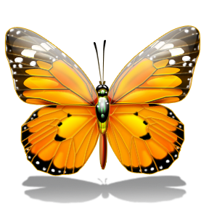

Trees

By Sarah Coleridge

The Oak is called the king of trees,  
The Aspen quivers in the breeze,  
The Poplar grows up straight and tall,  
The Peach tree spreads along the wall,  
The Sycamore gives pleasant shade,  
The Willow droops in watery glade,  
The Fir tree useful in timber gives,  
The Beech amid the forest lives.

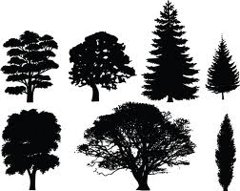

Wouldn’t You?

by John Ciardi

If I

Could go

As high

And low

As the wind

As the wind

As the wind

Can blow—

I’d go!

**Over in the Meadow**

Over in the meadow in a new little hive

Lived an old mother queen bee and her honeybees five.

“Hum,” said the mother,

“We hum,” said the five;

So they hummed and were glad in their new little hive.

Over in the meadow in a dam built of sticks

Lived an old mother beaver and her little beavers six.

“Build,” said the mother,

“We build,” said the six;

So they built and were glad in the dam built of sticks.

Over in the meadow in the green wet bogs

Lived an old mother froggie and her seven polliwogs.

“Swim,” said the mother.

“We swim,” said the ‘wogs;

So they swam and were glad in the green wet bogs.

Over in the meadow as the day grew late

Lived an old mother owl and her little owls eight

“Wink,” said the mother,

“We wink,” said the eight;

So they winked and were glad as the day grew late.

*Excerpt from OVER IN THE MEADOW by John Langstaff.*