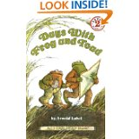

**Title:** Days with Frog and Toad

**By:** Arnold Lobel

**Contents:**

Tomorrow

The Kite

Shivers

The Hat

Alone

**Tomorrow**

**First Line: “**Toad woke up.”

**Last Line:** “He pulled the covers over his head and fell asleep.”

**Key word:** tomorrow

**List to do:** “Your pants and jacket are lying on the floor.”

“Your kitchen sink is filled with dirty dishes.”

“There is dust on your chairs.”

“Your windows need scrubbing.”

**Saying:** “I feel down in the dumps.”

**The Kite**

**First Line:** “Frog and Toad went out to fly a kite.”

**Last Line:** “It seemed to be flying way up at the top of the sky.”

**Key word:** kite

List to try to fly kite: “Toad ran across the meadow.”

“He waved the kite over his head.”

“He jumped up and down.”

“He shouted, ‘UP KITE UP!’”

**Shivers**

**First Line:** “The night was cold and dark.”

**Last Line:** “It was a good, warm feeling.”

**Key word:** shivers

**Recurring line:** “Maybe it was and maybe it wasn’t,” said Frog.

**Alone**

**First Line:** “Toad went to Frog’s house.”

**Last Line:** “They were two close friends sitting alone together.”

**Key word:** alone

**Recurring line:** “Frog was not there.”

**Similar lines:** “Frog was too far away to hear.”

“Frog was too far away to see.”

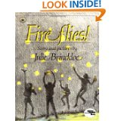

**Title:** Fireflies

**Story and pictures by:** Julie Brinckloe

**First Line:** “On a summer evening I looked up from dinner, through the open window to the backyard.”

**Last Line:** “The moonlight and the fireflies swam in my tears, but I could feel myself smiling.”

**Vocabulary:** flickered, fireflies, forked, nodded, cellar, jar, dusty, polished, dulling, banged, crickets, staring, blinked, dipping, soaring, patterns, crazy, barefoot, grasping, thrust, glowed, tremble, joy, dashed, waving, thrusting, blinked, swallow, dimmer, flung, aimed

**Compound Words:** treehouse, moonlight, flashlight

**The Horn Book:** “The delicate, sensitive story reflects a classic theme in children’s literature – the need to set something free in order to keep it…The tale is embellished with lovely, wistful pencil drawings of the boy and his friends leaping about in the twilight and of his expressive face showing his mingled joy and sadness. A simple, basic story, very gracefully presented.”

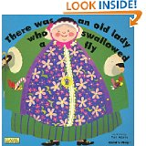

**Title:** There was an old lady who swallowed a fly

**Illustrated by:** Pam Adams

**A cumulative story:**

“There was an old lady who swallowed a cow.

I don’t know how she swallowed a cow!

She swallowed the cot to catch the dog.

She swallowed the dog to catch the cat.

She swallowed the cat to catch the bird.

She swallowed the bird to catch the spider.

That wriggled and wriggled and jiggled inside her.

She swallowed the spider to catch the fly.

I don’t know why she swallowed a fly.

Perhaps she’ll die.

**First Line:** “There was an old lady who swallowed a fly.”

**Ending:** “There was an old lady who swallowed a horse. She’s dead of course.”

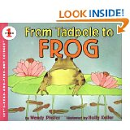

**Title:** From Tadpole to Frog

**By:** Wendy Pfeffer

**Illustrated by:** Holly Keller

**First Line:** “This is Frog Pond.”

**Last Line:** “Where are the frogs now?”

**Vocabulary:** whistle, hibernate, hideaway, melts, appear, return, creatures, arrived, stretching, fertilizes, hatch, tadpoles, wiggle, gills, tasty, burrow, hind, sprout, webbed, flick, capture, dragonflies

**Onomatopoeia:** Ba-ra-room

**Hyphenated Words:** jelly-covered, brownish-speckled, long-tailed

**Types of Frogs with information:** bullfrog, leopard/grass frog, pickerel frog, wood frog, gray tree frog, spring peeper frog

There are about 2,000 kinds of frogs.

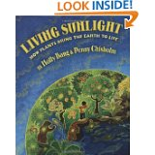

**Title:** Living Sunlight – How Plants Bring the Earth to Life

**By:** Molly Bang & Penny Chisholm

**Illustrated by:** Molly Bang

**Book Jacket:** “Without plant, we would have no oxygen. Without plants, we would have no food. Without plants, we could not live. Without plants, there would be no life on Earth. Read this book- and find out why.”

**First Line:** “Listen to me.”

**Last Line:** “You are living sunlight.”

**Vocabulary:** golden, burn, explodes, endless, Earth, melt, glaciers, create, pulse, circling, secret, plants, H2O, energy, chlorophyll, hydrogen, oxygen, trap, carbon dioxide (CO2), STEMS, photosynthesis, reptile, mammal, exhale, circling

**Hyphenated Words:** light-energy

**Onomatopoeia:** CHUNKA-CHUNKA-CHUNKA

**Notes About This Book:** “This is a book about life – about how life works. It is a book about how our sun gives us life through photosynthesis, the most important process on Earth. It is also a book about how photosynthesis connects all of life – how all life shares the same atoms, and how these atoms cycle on our planet.”

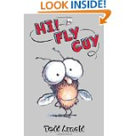

**Title:** Hi! Fly Guy

**By:** Tedd Arnold

**First Line:** “A fly went flying.”

**Last Line:** “And so began a beautiful friendship.”

**Vocabulary:** tasty, slimy, jar, pet, stomped, surprised, smartest, pests, fly swatter, rescue, judges, fancy, amazed, tricks

**Onomatopoeia:** BUZZ

**Awards:** Tallest Pet, Cutest Pet, Pet with Most Legs, Heaviest Pet, Smartest Pet

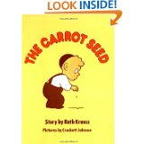

**Title:** The Carrot Seed

**Story by:** Ruth Krauss

**Pictures by:** Crockett Johnson (creator of Harold and the Purple Crayon)

**First Line:** “A little boy planted a carrot seed.”

**Last Line:** “And then, one day, a carrot came up just as the little boy had known it would.”

**Recurring Line:** “I’m afraid it won’t come up.”

**Vocabulary:** weeds, seed, sprinkled, ground, carrot

**Back Cover:** “When a little boy plants a carrot seed, he waters it, and he pulls the weeds, and he waits. Everyone tells him the seed won’t grow. But the little boy knows better…”

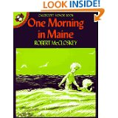

**Title:** One Morning in Maine

**By:** Robert McCloskey

**Caldecott Honor Book**

**First Line:** “One morning in Maine, Sal woke up.”

**Last Line:** “When we get home we’re going to have CLAM CHOWDER FOR LUNCH!”

**Vocabulary:** peeked, blink, wiggled, nightie, robe, slippers, squeezed, tongue, mirror, stairs, kitchen, chewing, wish, cautioned, beach, clams, fish hawk, loon, beak, herring, seal, slippery, seaweeds, stooping, shore, paused, sea gulls, mussels, solemnly, gravel, tenderly, grunted, village, reluctantly, moist, groceries, scrambling, feather, empty, tumble, aboard, preservers, outboard motor, coughed, sputtered, bay, drift, ashore, pinched, pliers, tunked, hammer, wrench, spark plug, greeting, confused, chuckling, dictated, appetite

**Onomatopoeia:** kasploosh!, Luh-hoo-hoo-hoo-hoo-hooh

**Place:** Buck’s Harbor

**Hyphenated Words:** bitter-tasting, ice-cream, dropped-out, good-by, brand-new

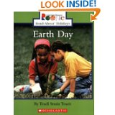

**Title:** Earth Day

**By:** Trudi Strain Trueit

**First Line:** “Imagine a city where the air is so dirty it is hard to breathe.”

**Last Line:** “Every day should be Earth Day when it comes to protecting the environment.”

**Vocabulary:** imagine, dirty, wildlife, oil, factories, pollution, gas fumes, chemicals, damaged, dangerous, conservation, Senator Gaylord Nelson, Earth Day, marches, parades, speeches, environment, pollution, outlawed, electric cars, recycle, reused, Australia, United States, Canada, Russia, vegetable, harmful, lettuce, conserve, protecting

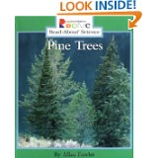

**Title:** Pine Trees

**By:** Allan Fowler

**First Line:** “Why are pine trees special?”

**Last Line:** “The paper in the book you are reading now might have been a pine tree!”

**Vocabulary:** evergreens, leaves, maple trees, leaves, needles, clusters (groups), fruit, conifers, cones, pinecones, woody, bumpy, pollen, United States, Canada, Alaska, Florida, hillsides, cedar, white pines, ponderosa pines, Douglas firs, timber. Resin (gummy material), tar, paving roads, pulp, timber

**Hyphenated Words:** thirty-story

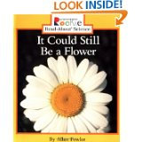

**Title:** It Could Still Be a Flower

**By:** Allan Fowler

**First Line:** “Do you have a favorite kind of flower?”

**Last Line:** “Enjoy them all!”

**Vocabulary:** roses, sweet William, black-eyed Susan, Queen Anne’s lace, morning glory, stems, shrubs, azalea, lilacs, magnolias, cherry blossoms, Hyacinths, bulbs, lily, asters, bloom, orchids, wildflowers, buds, rain forest

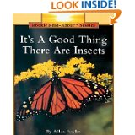

**Title:** It’s A Good Thing There Are Insects

**By:** Allan Fowler

**First Line:** “Sometimes we call them bugs.”

**Last Line:** “So the next time you see a beetle or a lady bug, remember – it’s a good thing there are insects!”

**Vocabulary:** insects, grasshopper, cicadas, water beetles, caterpillar, chrysalis, butterfly, bees, hive, mosquitoes, wasps, sting, locusts, silk, cocoon, silkworm, honey, pollen, monarch butterfly, reptiles, walking stick, firefly, lightning bug, cricket, beetle, lady bug, ants, fly

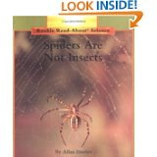

**Title:** Spiders Are Not Insects

**By:** Allan Fowler

**First Line:** “You can find spiders almost anywhere.”

**Last Line:** “But spiders do help people by eating insects that are harmful to plants or those that carry disease.”

**Vocabulary:** humid, deserts, woods, gardens, spiders, animals, arachnids, spotted fishing spider, jumping spider, ant lion, feelers (antennae), milkweed longhorn beetle, crab spider, frog-eating spider, Mexican red-legged tarantula, North America, brown recluse spider, female black widow spider, hourglass, poisonous, cling, silk threads, ballooning, net-casting spider, weave, webs, tunnel spider, sticky, trapped, Monarch butterfly, inject, poison, garden spider, grasshopper, bird spider (tarantula), golden silk spider, garden spider

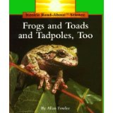

**Title:** Frogs and Toads and Tadpoles, Too

**By:** Allan Fowler

**First Line:** “Look at this bullfrog croaking!”

**Last Line:** “Now it’s a toad or a frog!”

**Vocabulary:** puff, spring peepers, twanging, bass string, banjo, amphibians, marshes, webbed, tadpole, gills, hatch, sticky tongue

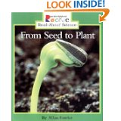

**Title:** From Seed to Plant

**By:** Allan Fowler

**First Line:** “Seeds are in a lot of the foods you eat.”

**Last Line:** “Isn’t it amazing that these tall tress grew from tiny seeds?”

**Vocabulary:** tomato seeds, watermelon seeds, peach pits, pollen, stamens, sip, nectar, clings, pistil, seedcase, eggs, slender, seedling, tough wall, pears, tough pod, peapod, peanut shell, fur, dandelion

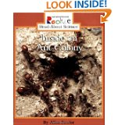

**Title:** Inside an Ant Colony

**By:** Allan Fowler

**First Line:** “Ants always seem to be busy.”

**Last Line:** “The ants work so hard that just watching them might make you tired!”

**Vocabulary:** scurry, ant colony, underground city, chambers, tunnels, aphids, queen ants, larvae, hatch sting, leaf-cutter ant, workers, carpenter ants, fire ants

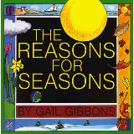

**Title:** The Reasons for Seasons

**By:** Gail Gibbons

**First Line(s):** “Spring. Summer. Autumn. Winter. These are the four seasons of the year.”

**Last Line:** “Earth and its many relationships to the sun are the reasons for the seasons.”

**Vocabulary:** sun, Earth, planet, seasons, revolve, rotation, Northern Hemisphere, Southern Hemisphere, equator, North Pole, axis, Spring Equinox, Vernal Equinox, migration, tilted, solstice, midday, climates, harvest, hibernation, alternating, South Pole

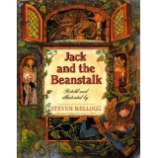

**Title:** Jack and the Beanstalk

**Retold and Illustrated by:** Steven Kellogg

**First Line:** “There was, once upon a time, a poor widow who had an only son named Jack and a cow named Milky-white.”

**Last Line:** “What with showing the golden harp and selling the golden eggs, Jack and his mother became very rich, and Jack married a great princess and they lived happily ever after.”

**Vocabulary:** widow, market, lad, swap, magical, dolt, parish, paltry beans, precious, attic, beanstalk, broiled, ogre, tidy, nod, tiptoed, peltered, rogue, muttered, larder, cupboards, harp

**Hyphenated Words:** Milky-white, funny-looking, fee-fi-fo-fum,

**Chant:**

“Fee-fi-fo-fum!”

I smell the blood of an Englishman.

Be he alive or be he dead,

I’ll grind his bones to make my bread.”

**Similes:** “bold as brass”

“snore like thunder”

“crept like a mouse”

**Connection to nursery rhyme “Jack and Jill” –** “The orge fell down and broke his crown and the beanstalk came tumbling after.”

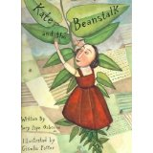

**Title:** Kate and the Beanstalk

**Written by:** Mary Pope Osborne

**Illustrated by:** Giselle Potter

**First Line:** “Long ago, a girl named Kate lived with her mother in a humble cottage.”

**Last Line:** “And the giantess served them a biscuit as big as a cow.”

**Vocabulary:** despair, plucky, beggar, creaky, extraordinary, exchange, horrified, starve, tossed, forlorn, crept, moonlit, beanstalk, misty, haze, astonishing, crystal, hobbled, castle, noble, knight, treasures, dreadful, grieving, widow, harp, farewell, lunged, cock’s crow, owl’s hoot, servants, gobbles, trembled, peeking, wagonload, hash, greedily, nod, magnificent, sparkled, diamonds, rubies, bellowed, haunting, chariot, peacocks, avenge, treachery, inheritance, disguised, beggar, quest, slain, wept

**Similes:** “His footsteps sounded like the booms of a cannon.”

“Then he put down his head and fell asleep, snoring as loud as thunder.”

“He flew like the wind across the sheep meadow.”

“The ground shook like an earthquake.”

“And the giantess served them a biscuit as big as a cow.”

**Chant:**

“Fee, Fi, Fo, Fum’un,

I smell the blood of an Englishwoman.

Be she alive or be she dead,

I’ll grind her bones to make my bread.”

**Publishers Weekly:** “A fresh face on an old favorite.”

**Booklist, starred review:** “Delightful.”

**Kirkus Reviews, starred review:** “Magical.”

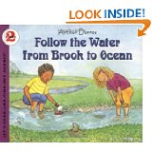

**Title:** Follow the Water from Brook to Ocean

**By:** Arthur Dorros

**First Line:** “After the next big rain storm, put your boots on and go outside.”

**Second Line:** “The next time you see water in a brook, a stream, or a river, you will know where it is going.”

**Vocabulary:** rain storm, boots, water, dripping, gush, drainpipes, flowing, trickles, brook, rushing, stream, river, puddle, pond, lake, ocean, rain, melting snow, soaks, trickles, algae, salamander, trout, springs, soaked, canoe, grind, erosion, otter, steep, bank, carve, canyons, Grand Canyon, Colorado River, cliff, waterfall, sprays, carve, bends, meanders, Missouri River “the Big Muddy”, reservoir, dam, piped, mouth, delta, plankton, microscope

**Hyphenated Words:** fast-moving, ground-up, fast-flowing, three-quarters

**Onomatopoeia:** plop, slap, clunk, thunk, sploosh

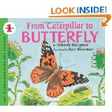

**Title:** From Caterpillar to Butterfly

**By:** Deborah Heiligman

**Illustrated by:** Bari Weissman

**First Line:** “Today a caterpillar came to school in a jar.”

**Last Line:** “And that caterpillar will turn into a beautiful butterfly.”

**Vocabulary:** metamorphosis, hatched, larva, silk, chrysalis, pupa, nectar, proboscis, sip, nectar, painted lady butterflies, monarch, black swallowtail, cabbage white, dogface butterfly, common blue, buckeye

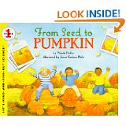

**Title:** From Seed to Pumpkin

**By:** Wendy Pfeffer

**Illustrated by:** James Graham Hale

**First Line:** “When spring winds warm the earth, a farmer plants hundreds of pumpkin seeds.”

**Last Line:** “And once again, they will grow – from seed to pumpkin.”

**Vocabulary:** roots, tubes, shoots, leaves, sunlight, energy, light, water, air, soak, sun, plant, prickly, jagged, smooth, stem, sprawl, twisted, tangled, bud, petals, orange umbrellas, swarms of bees, buzz, pollen, wither, bloomed, cling, vines, cornstalks, pumpkins, jack-o-lanterns, pumpkin pie, Thanksgiving, leaves, pumpkin patch

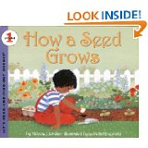

**Title:** How a Seed Grows

**By:** Helene J. Jordan

**Illustrated by:** Loretta Krupinski

**First Line:** “A seed is a little plant.”

**Last Line:** “It will grow into clover or it will grow into a bean plant like the ones you planted.”

**Vocabulary:** apple trees, carrots, corn, clover, wheat, flower, oak tree, beans, bush beans, lima beans, eggshells, flower pots, soil, sprinkle, carton, sunlight, windowsill, soaks, root, soil, water, sun, daisy, carrots, corn, clover

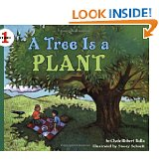

**Title:** A Tree Is a Plant

**By:** Clyde Robert Bulla

**Illustrated by:** Stacey Schuett

**First Line:** “A tree is a plant.”

**Last Line:** “Or in fall when they are covered with apples?

**Vocabulary:** apple tree, branched, blossoms, apple-blossom, leaves, trunk, roots, bark, maple, conifer, persimmon, palm, lemon, willow

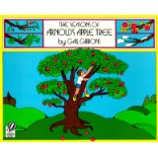

**Title:** The Season’s of Arnold’s Apple Tree

**By:** Gail Gibbons

**First Line:** “Arnold climbs up high into the branches of the apple tree.”

**Last Line:** “It is spring again…”

**Vocabulary:** branches, secret place, buds, blossoms, bees, nectar, honey, leaves, rustle, wind, tree house, shade, shelter, shower, juggling, red, golden, basket, cider press, apple cider, apple pie, popcorn, berries

**Hyphenated Words:** sweet-smelling, apple-blossom