Name ____________________________

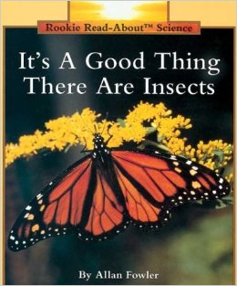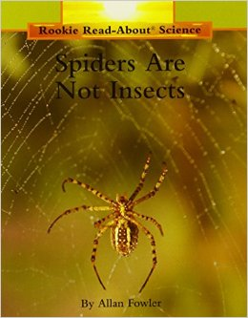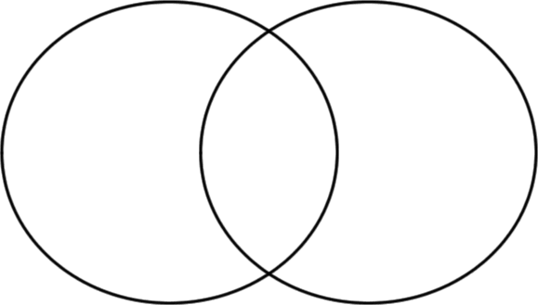Goal: I can compare spiders and insects.

* **__________________**
* **____________________**
* **__________________**
* **___________________**
* **__________________**
* **____________________**