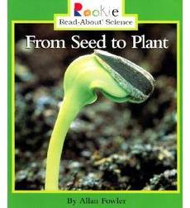Name ____________________________

RI.K.9

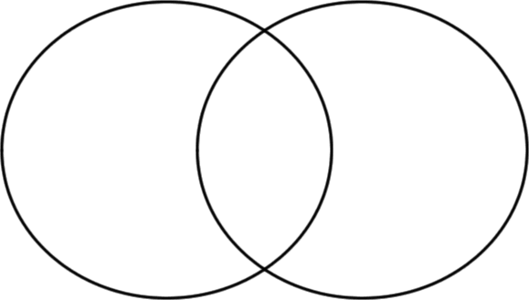Goal: I can compare two books on the same topic.

* **__________________**
* **____________________**
* **__________________**
* **___________________**
* **__________________**
* **____________________**