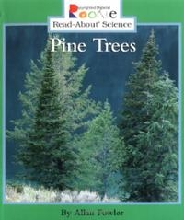**RI.K.9**

|  |  |  |
| --- | --- | --- |
| **Different** |  |  |
| **Same** |  | |