**Sample Kindergarten Work- RI.K.8**

**Mrs. Davis’ Class Mathias Elementary**

**M**

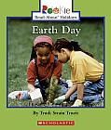The class read the Earth Day rookie reader together, and then the teacher gave each group a poster with four illustrations from the text.  Each group had to find evidence to support the author's statement about people not caring for the environment.

