Kindergarten
Understanding RL.K.9
Anchor Standard 9: Analyze how two or more texts address similar themes or topics to build knowledge or to compare the approaches the author’s take.
K | 1 | 2 | 3
With prompting and support, compare and contrast the adventures and experiences of characters in familiar stories. | [Independently] Compare and contrast the adventures and experiences of characters in stories. | Compare and contrast two or more versions of the same story (e.g. Cinderella stories) by different authors or from different cultures. | Compare and contrast the themes, settings, and plots of stories written by the same author about the same or similar characters (e.g. in books from a series).
*Note: This standard also supports Standard 3 (describing characters) in grades 1-5.

To achieve this standard, students first need to be able to

-Ask & answer questions about key details (RL.K.1)
-Retell the stories (RL.K.2)
-Identify characters in a story (RL.K.3)

About each of the stories you’ve chosen to compare AND compare and contrast adventures and experiences of characters in at least 2 different texts.

So is there a difference between an adventure/experience?
experience | adventure
Something that happens to you OR something you have done | An exciting or dangerous experience that involves risk or danger. These stories have a fast moving plot and involve experiences that are outside the character’s ordinary life.
An adventure IS an experience, but it has added risk & danger. An adventure is an experience, but not all experiences are an adventure. To help you think about comparing and contrasting characters, the texts in unit 5 are separated by experience or adventure.

Unit 5 Texts
Experience | Adventure
Koala Lou  Ferdinand  One Fine Day  The Paper Crane | Mr. Popper’s Penguins  Little Red Riding Hood  Lon PoPo  Arrow to the Sun  The Fool of the World and the Flying Ship  Rain Player  A Story A Story  The Story of Jumping Mouse  Something to Tell the Grandcows  Possum Magic

Planning for RL.K.9

Step 1:
Plan for assessment. What will my students do that lets me know they have met the standard? Will it be an observation or pencil/paper task?

Step 2:
Choose a text set (2 or more texts)

Step 3:
Choose features for your students to compare that will bring out the similarities and differences in the 2 texts (Making sure your students know the steps the Thinking Skill, Comparing & Contrasting).

Step 4:
GANAG your lesson.
Possible Goal: I can tell how 2 characters are the same and different.

Step 5:
Teach, assess, & score

Possible Lesson Sequence
Day 1:
Read Koala Lou, focusing on Standards 1-3. What does the text say/mean? Possible goals:
I can retell a story. *Students need to be able to identify and retell events in a story to be able to identify the adventure/experience.
I can identify the characters in a story.

Day 2:
Read The Paper Crane, focusing on Standards 1-3.
*Possum Magic is also a text talk book.

Day 3:
Teach “What is an experience?”
Goal: I can identify the experience of a character.
Reread portions of each text and identify the experiences of each character.

Day 4:
Compare the experiences of the characters. (This might be where we talk about experience vs. adventure.) using a matrix with provided features. Students can write or draw responses. Score students to RL.K.9 as students work. For some, the written responses will be appropriate, for some it might be observational.

Day 5: Start the process over with The Story of Jumping Mouse and Rain Player.

Possible Text Sets
Adventures | Experiences
Little Red Riding Hood  Lon PoPo | Koala Lou  The Paper Crane
The Story of Jumping Mouse  A Story A Story  Rain Player  Arrow to the Sun  Possum Magic | Once a Mouse  Why Mosquitoes Buzz in People’s Ears  Ferdinand
The Fool of the World and the Flying Ship
Something to Tell the Grandcows

Name: _________________________________________
Unit 5: A Great Big World RL.K.9

Book | 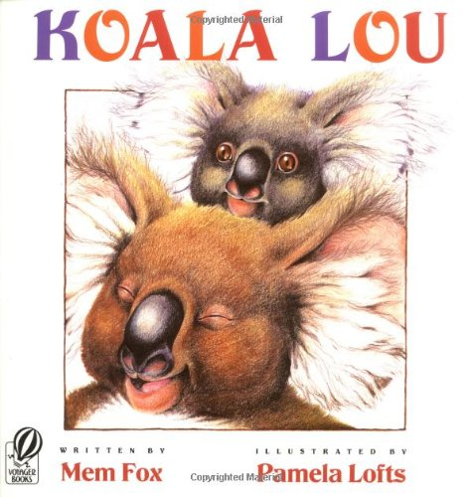 | 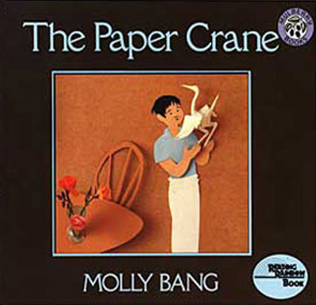
Who is the main character?
(RL.K.3)

What is the problem?
(RL.K.3)

What does the character do?
(How does the character respond?)

What is the solution?

How are the experiences the same?
They both __________________________________________________________

How are the experiences different?
Koala Lou ____________________________________________ but the family _______________________________________________________________________.

