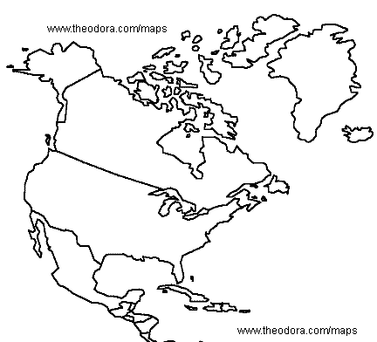

Animals

Landforms

Weather

Places

People