[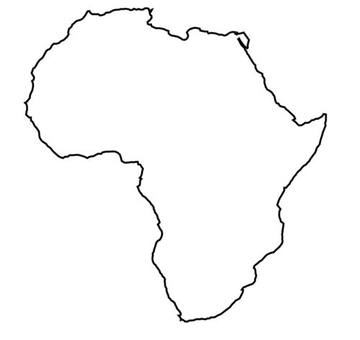](http://www.zonu.com/fullsize-en/2009-11-07-10926/Africa-outline-map.html) Africa

Things to See

Animals

Why I want to go there

Weather

People

North America

Things to See

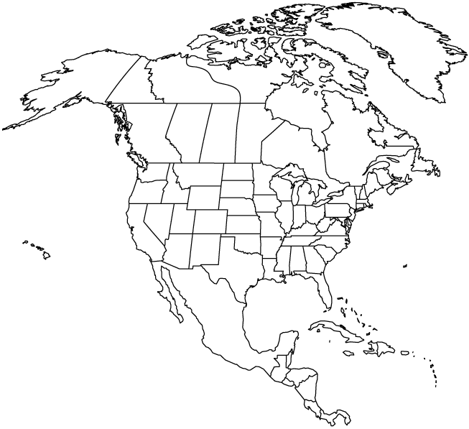

Land

Weather

Why I want to go there

south America

Things to See

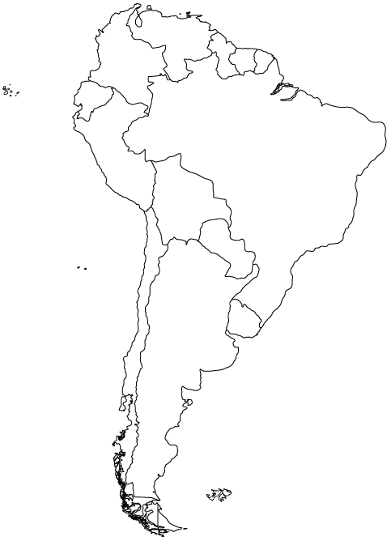

Land

Animals

Why I want to go there

Antarctica

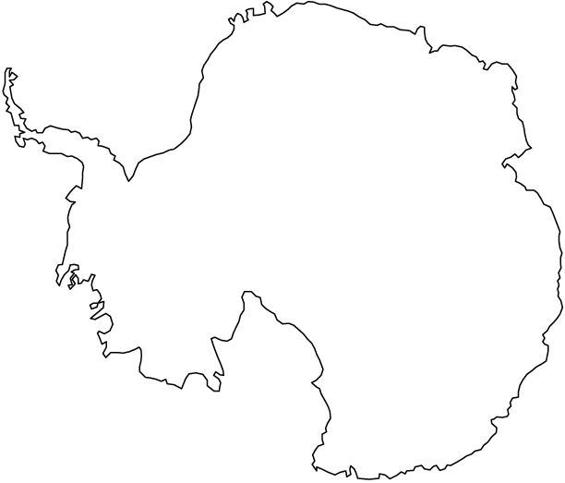

Things to See

People

Animals

Why I want to go there

Weather

Asia

Things to See

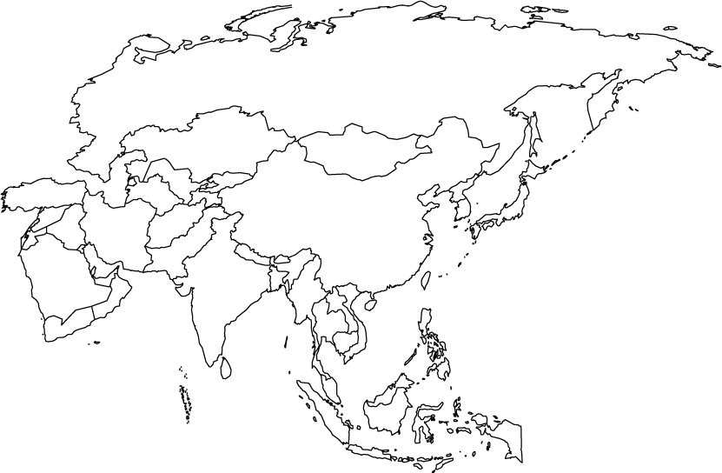

Australia

Animals

Why I want to go there

Land

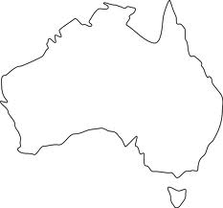

Things to See

Land

Animals

Why I want to go there

Europe

Things to See

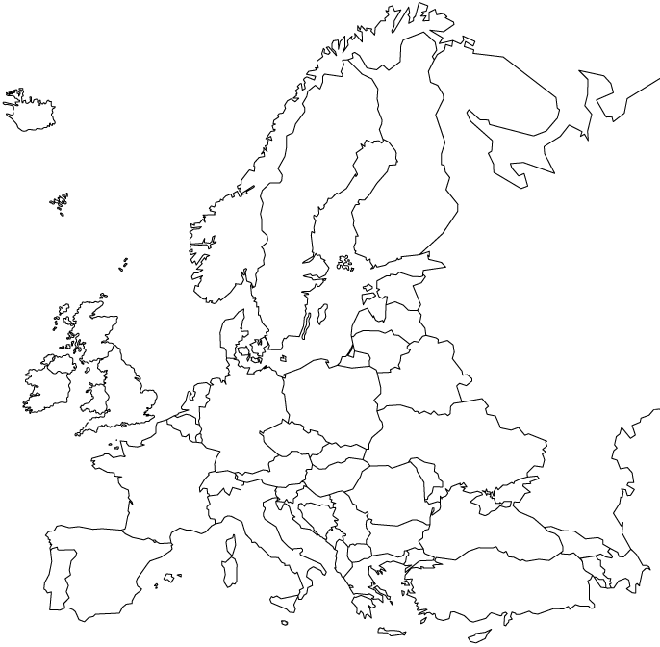

Weather

Why I want to go there

Other Facts

Land

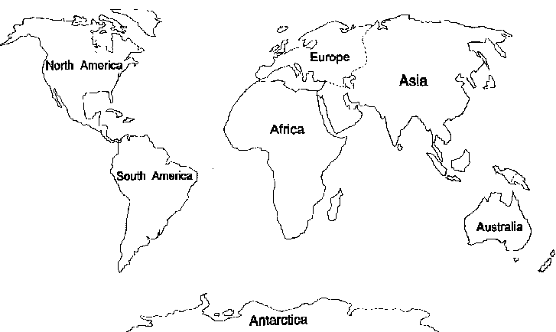

**The Seven Continents**

GOALS:

We can retell stories with details.

We can identify what is the same and what is different in two books.

Name ___________________