[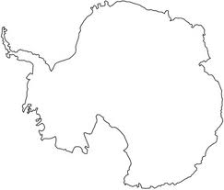](http://www.google.com/imgres?q=Antarctica+color&um=1&hl=en&rls=com.microsoft:en-us:IE-SearchBox&biw=1024&bih=616&tbm=isch&tbnid=_Re84fEjs68CeM:&imgrefurl=http://www.squidoo.com/country-flags-coloring-pages&docid=6IvadZkKu00RuM&imgurl=http://www.supercoloring.com/wp-content/main/2009_09/Antarctica-Map-coloring-page.png&w=327&h=279&ei=v9VPT6XnComxsALfisCsDg&zoom=1)

Landforms

Weather

Places

People

Animals