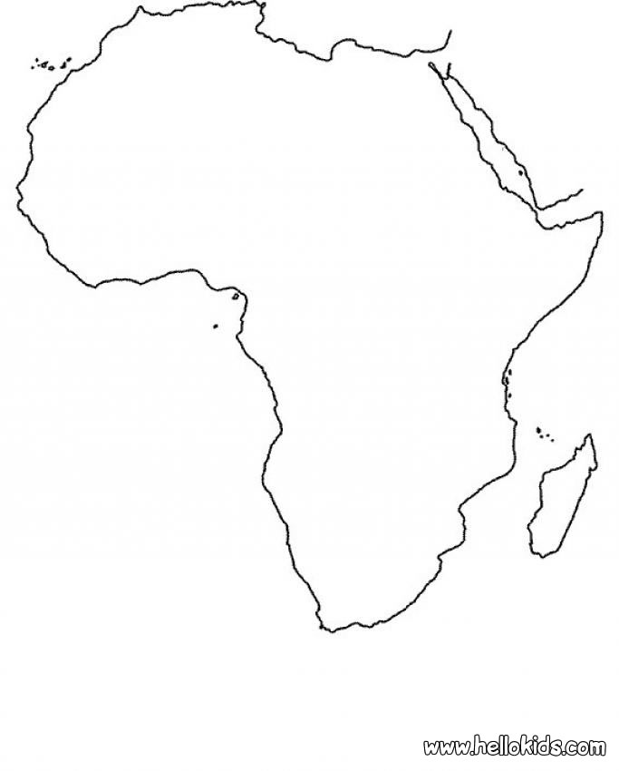

Landforms

Weather

Places

People

Animals