Name: ______________________________________

RL.K.3 CFA Post Assessment

1. Draw all characters from the book Koala Lou and circle the main character.

2. Circle the setting of this book.



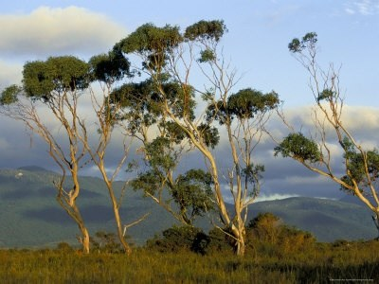

farm

gum trees

school

3. How does Koala Lou feel when she loses the race?





sad

crazy

happy

4. Events – verbally assessed during character drawings

3 2 1 0