South America
RI.K.2
W.K.2
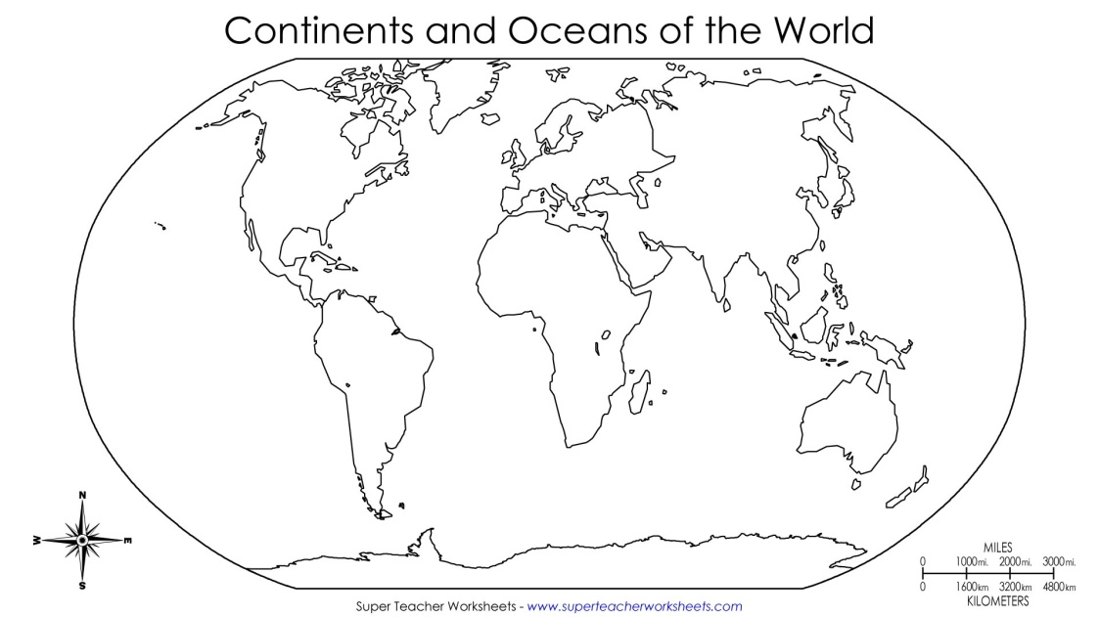  Find and color South America | Landmarks  Draw 1 landmark found in South America.
Types of Land  Draw 1 type of land found in South America. | Animals  Draw 1 animal found in South America.

__________________
__________________
__________________
__________________

