North America
RI.K.2
W.K.2
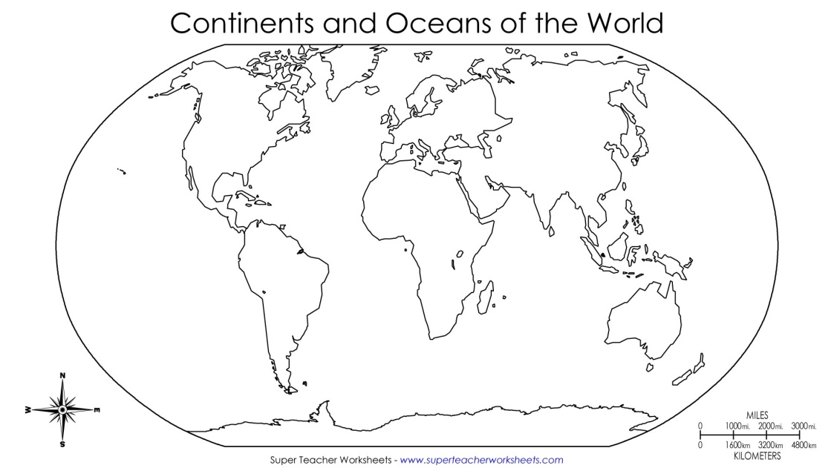  Find and color North America | Landmarks  Draw 1 landmark found in North America.
Types of Land  Draw 1 type of land found in North America. | Climate  Draw 1 type of climate found in North America.

____________________
____________________
____________________
____________________

