Asia
RI.K.2
W.K.2
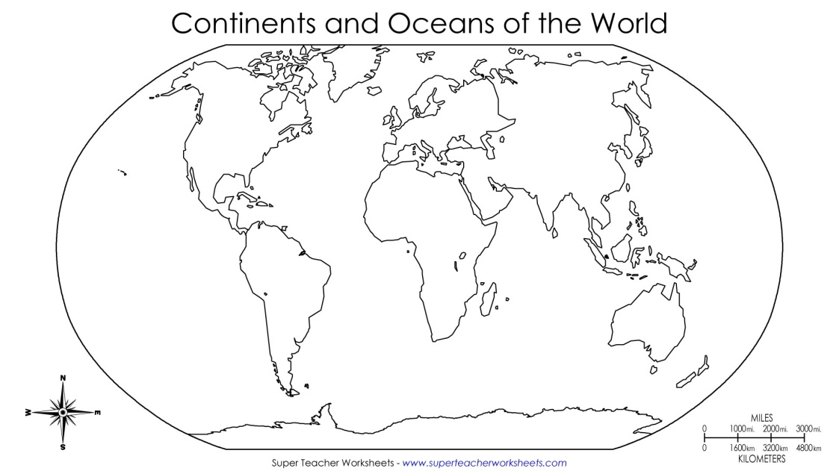  Find and color Asia | Landmarks  Draw 1 landmark found in Asia
Types of Land  Draw 1 type of land found in Asia. | Animals  Draw 1 animal found in Asia.

__________________
__________________
__________________
__________________

