Antarctica
RI.K.2
W.K.2
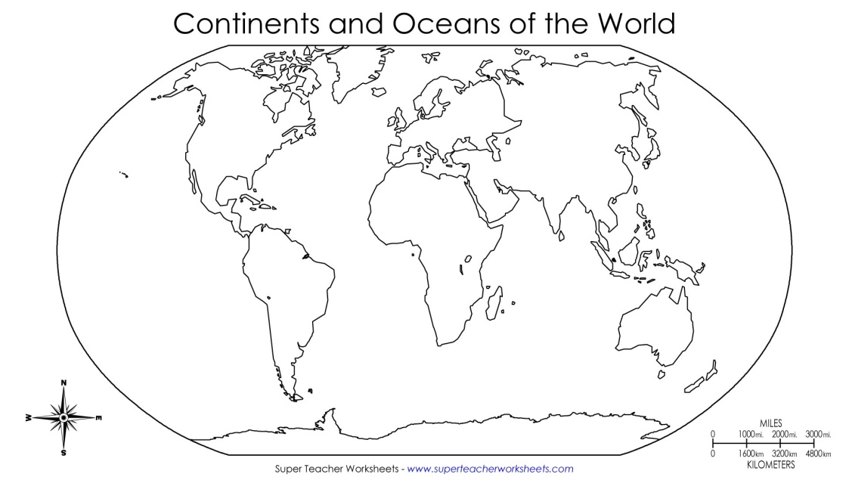  Find and color Antarctica | Types of Land and Water  Draw 1 type of land or water found in Antarctica
Climate  Draw the climate of Antarctica | Living Things  Draw 1 type of living thing found in Antarctica

__________________
__________________
__________________
__________________

