Africa
RI.K.2
W.K.2
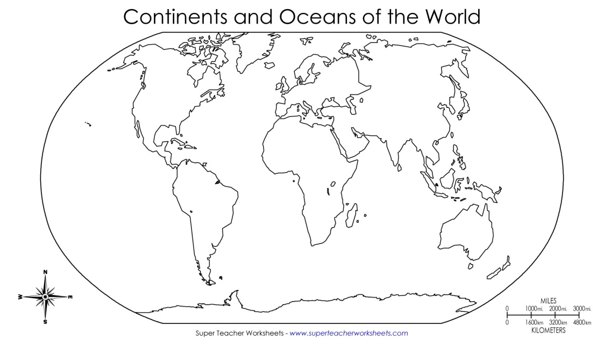  Find and color Africa | Landmarks  Draw 1 landmark found in Africa
Types of Land  Draw 1 type of land found in Africa | Animals  Draw 1 animal found in Africa

__________________
__________________
__________________
__________________

