Name_______________________________________________________

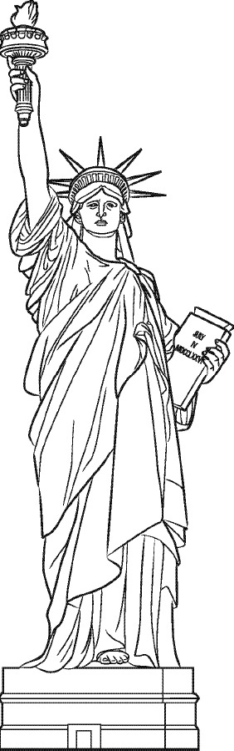

The Statue of Liberty has____

_________________________

_________________________

This stands for______________

________________________

______________________