Unit 4 | Unit Title: America: Symbols and Celebrations  Unit Essential Question: Why are symbols and celebrations important?
MATERIALS | Christmas by Trudi Strain Trueit  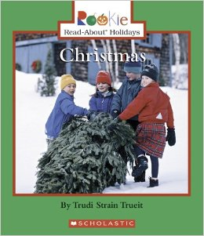
STANDARDS | RI.K.2-Identify the topic and retell key details of a text.
Lesson Structure | High Yield Strategies | Lesson Plan
GOAL  (2 minutes) | (8) Setting Objective and Providing Feedback | I can name the topic and retell details.
ACCESS PRIOR  KNOWLEDGE  (3minutes) | (6) Nonlinguistic Representations  (7) Cooperative Learning  (10) Cues, Questions and Advance Organizers | Show a picture of a Christmas tree.  How does your family celebrate Christmas?
NEW  INFORMATION | (3) Summarizing and Note Taking  (11) Teaching Specific Types of Knowledge | Read the book Christmas.  Complete class comparison matrix on butcher paper:  - Name the topic Christmas  Answer the questions with details from the book:  - Who celebrates Christmas?  - When do we celebrate?  - Why do we celebrate?  - How do we celebrate?
Grade___Kindergarten______ Date__January 5-6, 2014___
APPLICATION | Declarative  (3)Generating and Testing Hypotheses  (10) Cues, Questions and Advance Organizers | Procedural  (5) Homework and Practice | Students will complete an individual matrix on paper, retelling key details from the text.  (Students will add key details from the books Chanukah and Kwanzaa in the following lessons).
GOAL  (2 minutes) | (8) Setting Objective and Providing Feedback  (4) Reinforcing effort and Providing Recognition |  | I can name the topic and retell details.

WRITING: I can name the topic and give information (W.K.2).
Students will name the celebration, Christmas, and use their individual matrix to give information about the holiday.

Name: Date:

I can name the topic and retell details (RI.K.2).

 |  | 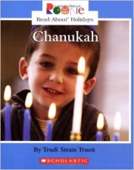 | 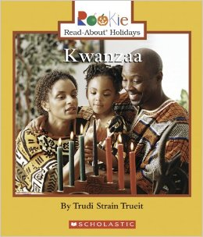
Who?
When?
Why?
How?

