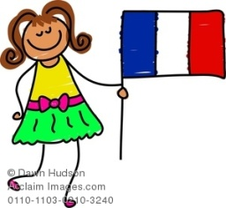**Family Flag Project**

Kindergarten is studying Family Celebrations and American Symbols. Please help your child create their very own flag, all about their family. In the past, families have included family celebrations, pictures, drawings, and/or fun family facts.

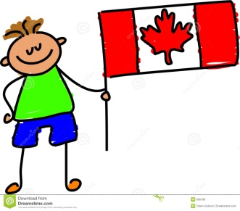Student’s will share their flag with their class and enjoy learning about each other’s family flag.