Name___________________

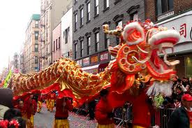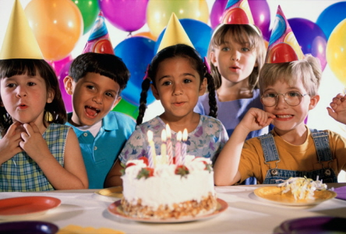I am five years old today.

The fireworks lit up the sky.

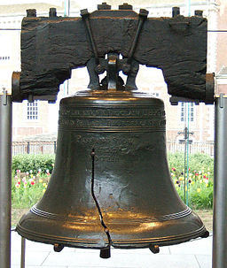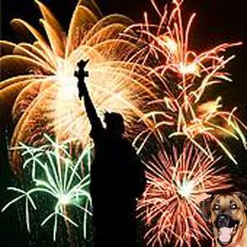

RI.K.7

With prompting and support, describe the relationship between illustrations and the text in which they appear.

G- I can find a picture that matches the story.

A- Picture of illustrator working- turn and talk

N-

Define illustrator-

Show an illustration from *Family Pictures*. Read the sentences one at a time and ask, which part of the painting illustrates this?

A- matching worksheet

G-