Statue of Liberty Facts

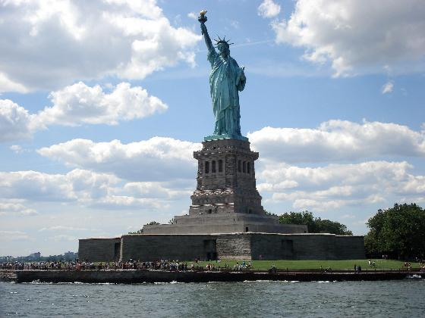

What **I already know** about the Statue of Liberty.