Liberty Bell Facts

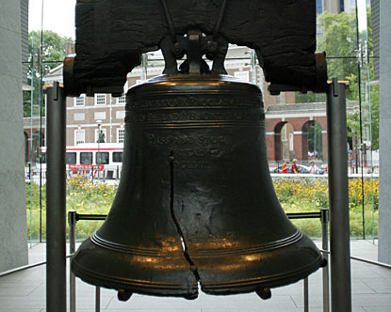

What **I already know** about the Liberty Bell.