Bald Eagle Facts

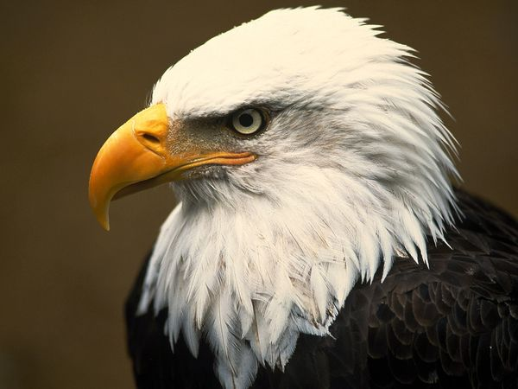

What **I already know** about the Bald Eagle.