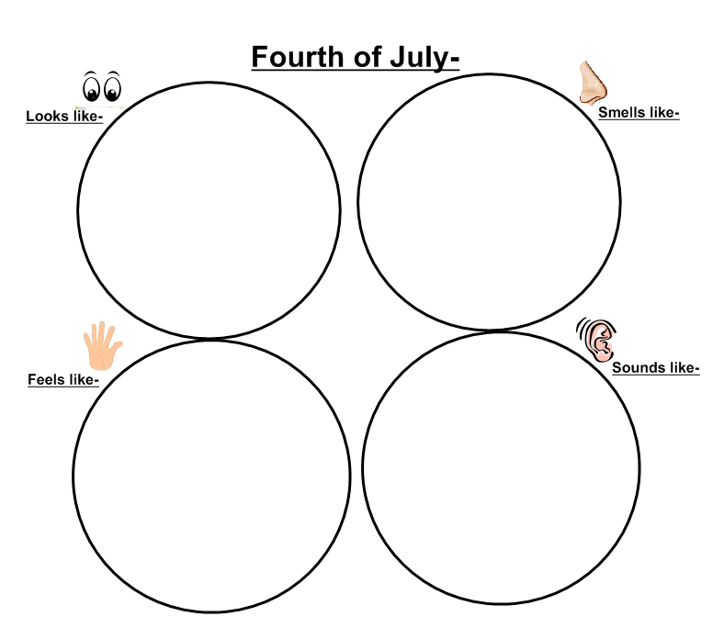Name_____________________________________________________________ Date_____________________________