**Liberty Bell Facts**

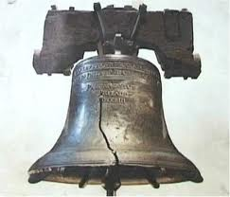

What **I already know** about the Liberty Bell.