**Chinese New Year Facts**

**[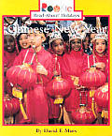](http://www.google.com/url?sa=i&rct=j&q=cinco+de+mayo+by+Trudi+Strain+Trueit&source=images&cd=&cad=rja&docid=mdUnT4RBxVz-hM&tbnid=Y1MXdplon2pzJM:&ved=0CAUQjRw&url=http://www.powells.com/biblio/62-9780531118399-0&ei=zx8MUcKVIu3U2QW1l4GgDg&bvm=bv.41867550,d.b2I&psig=AFQjCNH6QSkVjDPhZypLnsDzCcThHL2uFQ&ust=1359835466789339)**

What **I already know** about the Chinese New Year.