**Bald Eagle Facts**

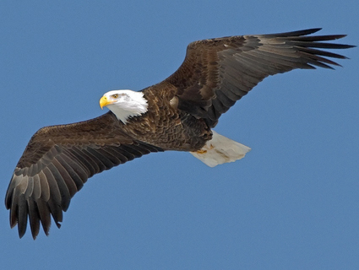

What **I already know** about the bald eagle.