Draw a picture of a firefighter.

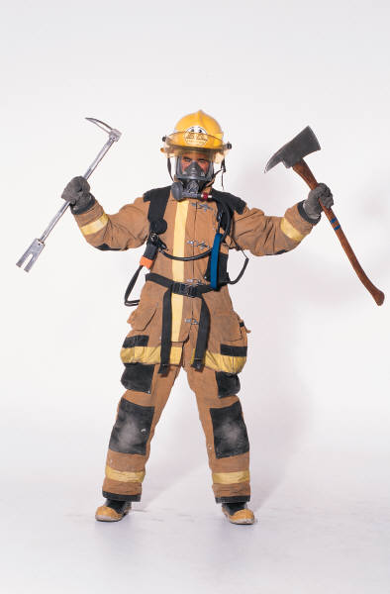

firefighter

Write what you have learned about a firefighter.