Goal:

I can tell how things are the same and different.

I can tell a story with pictures, sounds, or words I know.

APK: Have you ever been to a museum or an art gallery? Have you ever made a painting?

New Information: Look at 3 different pieces of art.

Jean-Francois Millet *First Steps-*1976

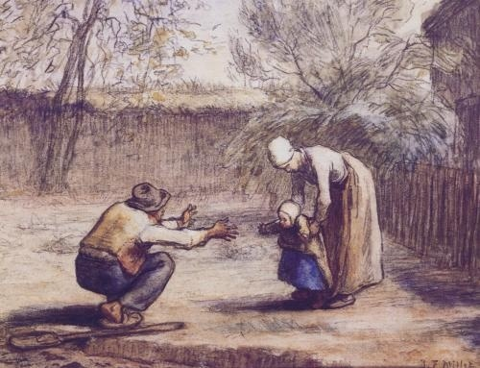

Vincent Van Gogh *First Steps, After Millet-1976*

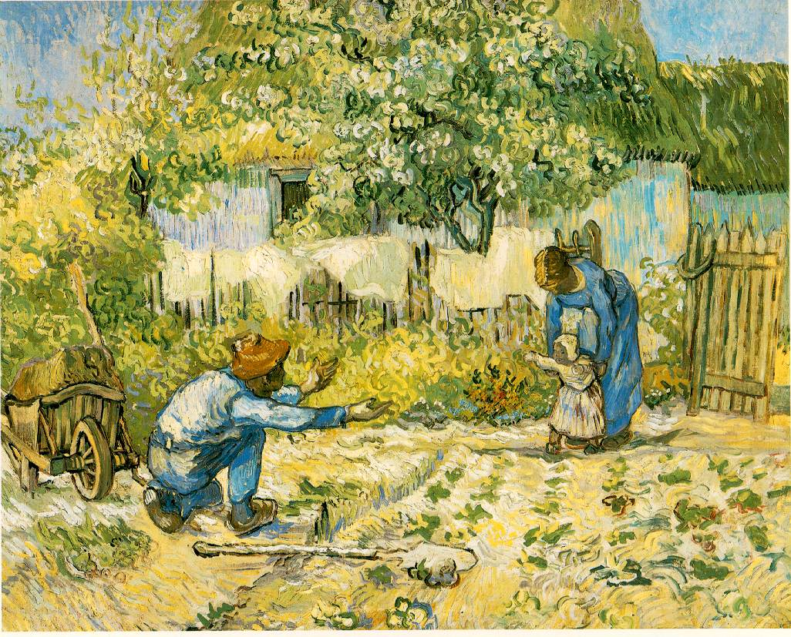

Pablo Picasso *Mother and Child (First Steps)-*1976

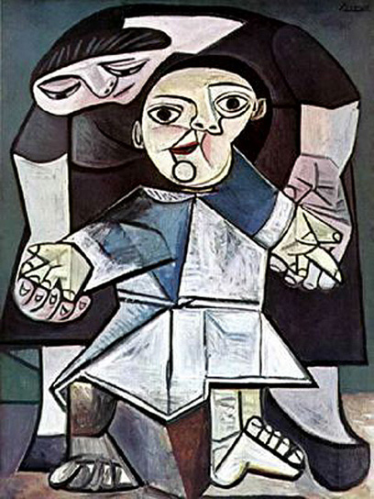

Questions:

1. What do you notice about these pictures? Who are these people?
2. Why do you think the painter or artist did…..
3. How are these pictures the same how are they different?

Model writing using letters, beginning and end sounds, sight words and complete sentences.

Application: Students will write about the picture(s) they are given using sounds they know, words, or complete sentences.

Goal: Restate the goal.