Unit 2 | Tell a Story, 1-2-3  Unit Essential Question: How are the beginning, the middle, and the end of a story different from each other?
Materials | Picture cards  Large paper for sorting
STANDARDS | RL.K.3 With prompting and support, identify characters, settings, and major events in a story.
Lesson Structure | High Yield Strategies |  | Lesson Plan
Goal  (2 minutes) | (8) Setting Objective and Providing Feedback  (4) Reinforcing effort and Providing Recognition |  | I can identify characters and settings.  “How well do you think you will do?”  Score perceived performance of the goal
Access Prior Knowledge  (3minutes) | (6) Nonlinguistic Representations  (7) Cooperative Learning  (10) Cues, Questions and Advance Organizers |  | Display a version of The Three Little Pigs that you have previously read.  “What is your favorite part of this story?”
New Information  (5 minutes) | (3) Summarizing and Note Taking  (5) Homework and Practice  (11) Teaching Specific Types of Knowledge |  | Introduce the steps for Classifying  - What do I want to classify?  - What things are alike that could be put into a group?  - How are the things alike?  - What other groups can I make and how are the things alike in each group?  - Does everything now fit into a group?  - Would it be better to split up any of the groups or put groups together?
Application  (20 minutes) | Declarative  (2) Indentifying Similarities and Differences  (3)Generating and Testing Hypotheses  (10) Cues, Questions and Advance Organizers | Procedural  (5) Homework and Practice | Model using the picture cards from Pancakes for Breakfast to classify by characters and setting  - What do I want to classify? pictures  - What things are alike that could be put into a group? Characters, setting  - How are the things alike? These are all characters  - What other groups can I make and how are the things alike in each group? These are all settings  - Does everything now fit into a group?  - Would it be better to split up any of the groups or put groups together?  Ask students to cut their picture cards apart and classify them by character and setting
Goal  (2 minutes) | 8) Setting Objective and Providing Feedback  (4) Reinforcing effort and Providing Recognition |  | Revisit the goals:  I can use information from a text to classify animals.  I can describe how they are grouped.  “How well do you think you did?”  Score perceived performance of the goal

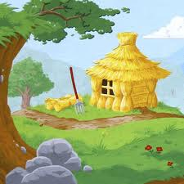 | 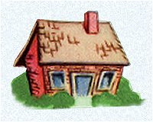 | 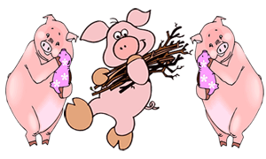
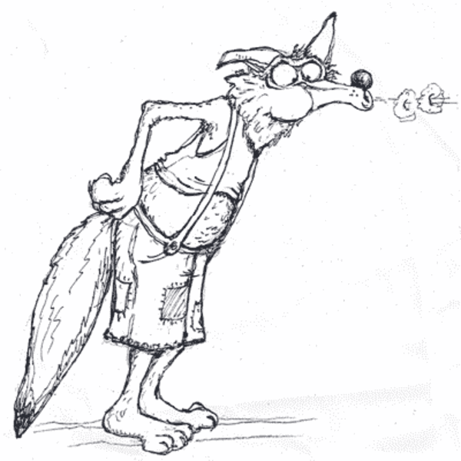 | 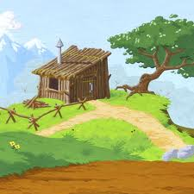 | 