Name____________________

**RI.K.5 – I can identify the parts of a book (front cover, back cover, title page).**

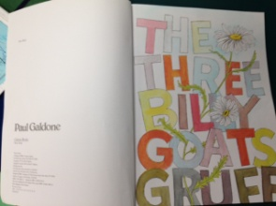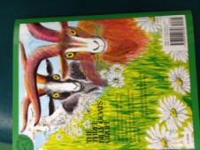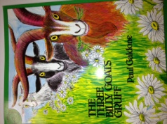**Front F**

Title page

Back Cover

Front Cover