|  |  |
| --- | --- |
| Lesson: Verbs & Adjectives | |
| Standard:  L.K.5.b Demonstrate understanding of frequently occurring verbs and adjectives by relating them to their opposite. | |
| Goal  (8) Setting Objectives and Providing Feedback  (4) Reinforcing effort and Providing Recognition | G I can identify a verb.  *Score yourself |
| Access Prior Knowledge  (6) Nonlinguistic Representations  (7) Cooperative Learning  (10) Cues, Questions and Advance Organizers | A T/T- picture of kids **playing** soccer. |
| New Information  (3) Summarizing and Note Taking  (5) Homework and Practice  (11) Teaching Specific Types of Knowledge | NWhat is a verb? “A word used to show an action.”  *watch Brainpopjr- “Verbs” |
| Application  (2) Identifying Similarities and Differences  (9) Generating and Testing Hypotheses  (10) Cues, Questions and Advance Organizers | A *Brainpopjr Quiz  Whole group; create a list of verbs adding visuals, |
| Generalize  (8) Setting Objectives and Providing Feedback  (4) Reinforcing effort and Providing Recognition | G I can identify a verb.  *Score yourself |

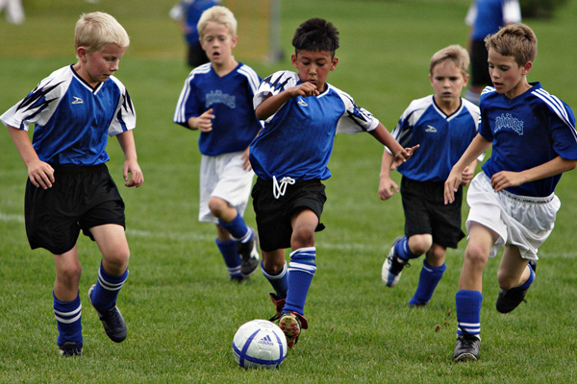

|  |  |
| --- | --- |
| Lesson: Verbs & Adjectives | |
| Standard:  L.K.5.b Demonstrate understanding of frequently occurring verbs and adjectives by relating them to their opposite. | |
| Goal  (8) Setting Objectives and Providing Feedback  (4) Reinforcing effort and Providing Recognition | G I can identify a verb in a sentence.  *Score yourself |
| Access Prior Knowledge  (6) Nonlinguistic Representations  (7) Cooperative Learning  (10) Cues, Questions and Advance Organizers | A T/T- Jack be Nimble  *What is the verb? |
| New Information  (3) Summarizing and Note Taking  (5) Homework and Practice  (11) Teaching Specific Types of Knowledge | NReteach what is a verb? “A word used to show an action.”  *Revisit list of verbs. |
| Application  (2) Identifying Similarities and Differences  (9) Generating and Testing Hypotheses  (10) Cues, Questions and Advance Organizers | A Pull from the book Pigs. Have students identify/circle the verbs in the sentence. |
| Generalize  (8) Setting Objectives and Providing Feedback  (4) Reinforcing effort and Providing Recognition | G I can identify a verb in a sentence.  *Score yourself |

|  |  |
| --- | --- |
| Lesson: Verbs & Adjectives | |
| Standard:  L.K.5.b Demonstrate understanding of frequently occurring verbs and adjectives by relating them to their opposite. | |
| Goal  (8) Setting Objectives and Providing Feedback  (4) Reinforcing effort and Providing Recognition | G I can identify an adjective.  *Score yourself |
| Access Prior Knowledge  (6) Nonlinguistic Representations  (7) Cooperative Learning  (10) Cues, Questions and Advance Organizers | A T/T- picture of a muddy puppy. (maybe write the adjectives they say around the picture.) |
| New Information  (3) Summarizing and Note Taking  (5) Homework and Practice  (11) Teaching Specific Types of Knowledge | NWhat is an adjective?  “A word used to describe something or someone.”  LOOKS like, SOUNDS like, FEELS like, TASTE like…  *watch Brainpopjr- “Adjectives & Adverbs” |
| Application  (2) Identifying Similarities and Differences  (9) Generating and Testing Hypotheses  (10) Cues, Questions and Advance Organizers | A *Brainpopjr Quiz  Whole group; create a list of adjectives that can describe your room. |
| Generalize  (8) Setting Objectives and Providing Feedback  (4) Reinforcing effort and Providing Recognition | G I can identify an adjective.  *Score yourself |

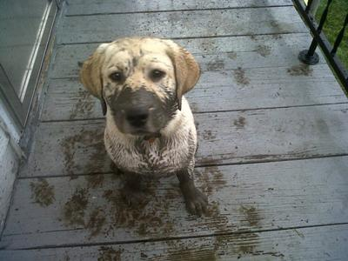

|  |  |
| --- | --- |
| Lesson: Verbs & Adjectives | |
| Standard:  L.K.5.b Demonstrate understanding of frequently occurring verbs and adjectives by relating them to their opposite. | |
| Goal  (8) Setting Objectives and Providing Feedback  (4) Reinforcing effort and Providing Recognition | G I can identify an adjective in a sentence.  *Score yourself |
| Access Prior Knowledge  (6) Nonlinguistic Representations  (7) Cooperative Learning  (10) Cues, Questions and Advance Organizers | A T/T- Tell your neighbor a word that describes the classroom. |
| New Information  (3) Summarizing and Note Taking  (5) Homework and Practice  (11) Teaching Specific Types of Knowledge | NWhat is an adjective?  “A word used to describe something or someone.”  LOOKS like, SOUNDS like, FEELS like, TASTE like… |
| Application  (2) Identifying Similarities and Differences  (9) Generating and Testing Hypotheses  (10) Cues, Questions and Advance Organizers | A Whole group; complete a Mad Lib…fill in the verb/adjective to complete the story. Read and repeat with different words. |
| Generalize  (8) Setting Objectives and Providing Feedback  (4) Reinforcing effort and Providing Recognition | G I can identify an adjective in a sentence.  *Score yourself |

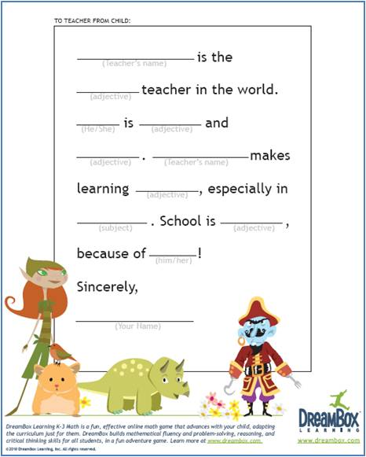

|  |  |
| --- | --- |
| Lesson: Verbs & Adjectives | |
| Standard:  L.K.5.b Demonstrate understanding of frequently occurring verbs and adjectives by relating them to their opposite. | |
| Goal  (8) Setting Objectives and Providing Feedback  (4) Reinforcing effort and Providing Recognition | G I can match verbs and adjectives to their opposite.  *Score yourself |
| Access Prior Knowledge  (6) Nonlinguistic Representations  (7) Cooperative Learning  (10) Cues, Questions and Advance Organizers | A T/T- pictures; dirty dog/clean dog. |
| New Information  (3) Summarizing and Note Taking  (5) Homework and Practice  (11) Teaching Specific Types of Knowledge | NWhat does opposite mean? |
| Application  (2) Identifying Similarities and Differences  (9) Generating and Testing Hypotheses  (10) Cues, Questions and Advance Organizers | A Smart Board lesson; draw a line to match the verb/adjectives with its opposite. |
| Generalize  (8) Setting Objectives and Providing Feedback  (4) Reinforcing effort and Providing Recognition | G I can match verbs and adjectives to their opposite.  *Score yourself |



