Unit 1 | Unit Title: A Colorful Time with Rhythm and Rhyme  Unit Essential Question: How do questions help us learn?
MATERIALS | 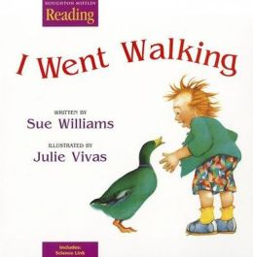  I Went Walking by Sue Williams
STANDARDS | RL.K.1
Lesson Structure | High Yield Strategies | Lesson Plan
GOAL  (2 minutes) | (8) Setting Objective and Providing Feedback | I can answer questions about pictures in a story.
ACCESS PRIOR  KNOWLEDGE  (3minutes) | (6) Nonlinguistic Representations  (7) Cooperative Learning  (10) Cues, Questions and Advance Organizers | Show four pictures (mountain, beach, forest, farm) and ask students, “Where would you like to walk?”
NEW  INFORMATION | (3) Summarizing and Note Taking  (11) Teaching Specific Types of Knowledge | Introduce how to answer in a complete sentence.
APPLICATION | Declarative  (3)Generating and Testing Hypotheses  (10) Cues, Questions and Advance Organizers | Procedural  (5) Homework and Practice | As you do a picture walk of the book, I Was Walking, ask questions as you go.
GOAL  (2 minutes) | (8) Setting Objective and Providing Feedback  (4) Reinforcing effort and Providing Recognition |  | I can answer questions about a story.
Grade___Kindergarten______ Date_______________

